RC BAJA
DRIVETRAIN & CHASSIS

By

Boe Hartman

Team Member:
Jarvis Hudnall

ABSTRACT

The object of this report is to design, manufacturer, and build an RC Baja Car to compete in the annual ASME RC Baja Competition.

In order to design, manufacture, and build the RC Baja Car, various methods and approaches are utilized throughout to meet the specified criteria of the competition along with the teams’ personal requirements. Initially, after an overall design was acquired, analysis is done to ensure a working device. Analysis such as power requirements to verify the motor will meet ROAR requirements and suffice for the 4wd system utilized in the device. Statics and dynamics analysis are utilized on individual components accounting for the overall weight to ensure the device withstands all forms of testing along with the abuse of the competition. In addition, decision matrices and material research are conducted to certify the best material is chosen for device. Next the manufacturing methods utilized such as, 3D printing for the chassis and differential housing’s along with machining for the drivetrain components are performed in order to assemble/build and test the RC Baja Car.

Testing of the device shows to meet the specified requirements along with competitively competing in the competition. The RC Baja Car is capable of achieving 15 mph in 5 seconds. Each component of the device is able to withstand the torque the car experiences underload when achieving maximum speed off 22.5 mph. The chassis of the RC Baja Car does not deflect more than 5/16 of an inch during testing and standard driving.

Keywords: RC Baja Car, 3D Printing/Machining, Testing.

Contents
ABSTRACT 2
1. INTRODUCTION 18
a. Description 18
b. Motivation 18
c. Function Statement 18
d. Requirements 18
e. Engineering Merit 19
f. Scope of Effort 19
g. Success Criteria 19
h. Stakeholders 19
2. DESIGN & ANALYSIS 20
a. Approach: Proposed Solution 20
b. Design Description 20
c. Benchmark 21
d. Performance Predictions 21
e. Description of Analysis 21
f. Scope of Testing and Evaluation 21
g. Analysis 21
I. Analysis 01 – Power Required to Accelerate Vehicle 21
II. Analysis 02 – RPM, Gear Ratio, Required Torque 22
III. Analysis 03 – Minimum Chassis Thickness 22
IV. Analysis 04 – Central Driveshaft Diameter 22
V. Analysis 05 – CV Axle Diameter 22
VI. Analysis 06 – Tire size/Diameter 23
VII. Analysis 07 – Motor Mount Thickness 23
VIII. Analysis 08 – Rear Axle Diameter 23
IX. Analysis 09 – Bending & Shear stress, 4 ft Drop 24
X. Analysis 10 – Thickness of Lower Diff Connecting Pin 24
XI. Analysis 11 – Connecting Bolt Shear Stress Analysis 24
XII. Analysis 12 – Thickness of Upper Diff Connecting Pin 25
h. Device : Parts, Shapes, and Conformation 25
i. Device Assembly 25
j. Technical Risk Analysis 26
k. Failure Mode Analysis 26
l. Operation Limits and Safety 26
3. METHODS & CONSTRUCTION 27
a. Methods 27
i. Process Decisions 27
b. Construction 28
i. Description 28
ii. Drawing Tree, Drawing ID’s 28
iii. Parts 29
Fall: 29
iv. Manufacturing Issues 29
Fall: 29
v. Discussion of Assembly 29
4. TESTING 30
a. Introduction 30
b. Method/Approach 30
c. Test Process 31
d. Deliverables 31
5. BUDGET 32
- Parts 32
b. Outsourcing 32
c. Labor 32
d. Estimated Total Project Cost 32
e. Funding Source 33
f. Winter Updates 33
g. Spring Updates 33
6. SCHEDULE 34
a. Design 34
b. Construction 34
c. Testing 35
7. PROJECT MANAGEMENT 36
a. Human Resources 36
b. Physical Resources 36
c. Soft Resources 37
d. Financial Resources 37
8. DISCUSSION 38
a. Design 38
b. Construction 39
c. Testing 39
9. CONCLUSION 40
a. Design 40
b. Construction 41
c. Testing 41
10. ACKNOWLEDGEMENTS 42
References 43
APPENDIX A - Analysis 44
Appendix A01 – Power Required to Accelerate Vehicle 44
Appendix A02 – RPM, Gear Ratio, Required Torque 45
Appendix A03 – Minimum Chassis Thickness 46
Appendix A04 – Central Driveshaft Diameter 47
Appendix A05 – CV Axle Diameter 48
Appendix A06 – Tire Size/Diameter 49
Appendix A07 - Motor Mount Thickness 50
Appendix A08 – Rear Axle Diameter 51
Appendix A09 – Bending & Shear Stress, 4 ft Drop 52
Appendix A10 – Thickness of Lower Diff Connecting Pin 53
Appendix A11 – Connecting Bolt Shear Stress Analysis 54
Appendix A12 – Thickness of Upper Diff Connecting Pin 55
APPENDIX B - Drawings 56
Appendix B01 – Drawing Tree 56
Appendix B02 – Drawing Index 57
Appendix B03 –BEH-10-001 – FRONT SUB-ASSEMBLY 58
Appendix B04 – BEH-10-002 – FULL RC CAR ASSEMBLY 59
Appendix B05 – BEH-20-001 - CENTRAL DRIVESHAFT 60
Appendix B06 – BEH-20-002 – DIFF PIN 61
Appendix B07 – BEH-20-003 – MAIN CHASSIS 62
Appendix B08 – BEH-20-004 – MOTOR MOUNT 63
Appendix B09 – BEH-20-005 - REAR AXLE 64
Appendix B10 – BEH-20-006 – LOWER DIFF COVER 65
Appendix B11 – BEH-20-007 – UPPER DIFF COVER 66
Appendix B12 – BEH-20-008 – CENTRAL DRIVESHAFT BEARING MOUNT 67
Appendix B13 – BEH-20-009 – BUMPER SPACER 68
Appendix B14 – BEH-20-010 – BUMPER 69
APPENDIX C – Parts List and Costs 70
APPENDIX D – Budget 71
APPENDIX E - Schedule 72
Appendix F – Expertise and Resources 74
Appendix F01 Decision Matrix for Drive Type 74
Appendix F02 Decision Matrix for Material Selection 75
Appendix F03 Decision Matrix for Chassis Components Manufacturing process 76
Appendix F04 Decision Matrix for Drivetrain Components Manufacturing process 77
APPENDIX G – Testing Report 78
Appendix G1 78
Appendix G1.1 – Procedure Checklist 78
Appendix G1.2 – Data Forms 78
Appendix G1.3 – Raw Data 78
Appendix G1.4 – Evaluation Sheet 78
Appendix G1.5 – Schedule 78
Appendix G2 78
Appendix G2.1 – Procedure Checklist 78
Appendix G2.2 – Data Forms 78
Appendix G2.3 – Raw Data 78
Appendix G2.4 – Evaluation Sheet 79
Appendix G2.5 – Schedule (Testing) 79
Appendix G3 (Replace with test title here) 79
Appendix G3.1 – Procedure Checklist 79
Appendix G3.2 – Data Forms 79
Appendix G3.3 – Raw Data 79
Appendix G3.4 – Evaluation Sheet 79
Appendix G3.5 – Schedule (Testing) 79
Appendix H – Resume 80

1. INTRODUCTION

Description

There is a Baja race that requires an engineered RC car and the main parts that will need to be engineered are the suspension, steering, drivetrain, and chassis. The design of the project will be split up between drivetrain/chassis and suspension/steering. The purpose of the drivetrain and chassis are to power, move, and support the vehicle using engineering methods to validate its readiness for the competition for the RC Baja challenges.

Motivation

This project was motivated by a need for a device that would race competitively in a Baja and drag race, along with a Solemn time trial. As a requirement to ABET accreditation combined with racing and automotive interests the RC Baja Car project was the perfect fit for both team members.

Function Statement

The Drivetrain provides a means for motion by harnessing the energy of the motor and applying it through a series of gearboxes, driveshafts, and axles. The Chassis provides an area for securing necessary components but primarily provides strength and rigidity to the RC Baja Car.

Requirements

The design requirements are created to ensure the RC Baja Car will withstand all trials for testing and RC Baja challenges.

- The RC car must be all-wheel drive.
- The RC car must be able to support a four-foot drop.
- The total length of the RC car must be no greater than 24 inches.
- There must be independent suspension on all four wheels.
- Must cost less than $700 to make.
- The driveshaft must be straight and dead center to the vehicle within 5% tolerance.
- RC car must include 2 secondary gear boxes with two 90deg worm gears.
- RC car must include 1 main gear box which includes a ring and bevel gear.
- The RC car must have four CV axles with a shaft tolerance of + - 1/8 inch.
- The drive shaft must resist a minimum of 15 ft-lbs of toque.
- The chassis must not deflect more than a 5/16 in.
- The chassis must be able to resist 10 lbs of impact force applied to any component on the device.
- The chassis must weigh no more than 10 lbs.
- The chassis must be able to maintain durability at 15+ mph.
- The RC Car must be able to accelerate to 15mph in 5 seconds.
- All components must be able to support the necessary torque to move the device 22.5 mph.
- The RC Car must support a crash at 22.5 mph.
- All components must satisfy a safety factor of 2 to support the weight of the vehicle. (Assume a weight of 6 pounds)

Engineering Merit

Engineering methods that will be used throughout the design process of the project include but are not limited to; Statics when analyzing the structural ability within the chassis and a variety of other parts, Dynamics when analyzing the device in motion such as the gears, Mechanics of Materials in order to achieve a lightweight rigid design to ensure optimal material selection. Additional analysis will be done to find maximum energy efficiency.

Scope of Effort

The scope regarding drivetrain and chassis will include an all-wheel drive system, two secondary gear boxes, four cv axles, two main driveshafts, one main gear box, along with frame and supporting structural components.

The scope regarding suspension and steering will include independent suspension for all four corners of the vehicle, all suspension related structural components (control arms), front and rear steering components including structural supporting members and steering knuckles.

Success Criteria

The RC Baja car fulfills all requirements stated in 1d. and completes all three challenges described in the ASME RC Baja Car contest rules.

Stakeholders

The stakeholders within this project include Professor Pringle, Professor Choi, and Chris Berkshire. Professors Pringle and Choi assisted in vehicle design and analysis. Chris Berkshire assisted in machining and manufacturing processes.

2. DESIGN & ANALYSIS

a. Approach: Proposed Solution

The drivetrain and chassis must allow the RC Baja car to competitively compete and successfully complete the ASME RC Baja Car competition. The RC Baja Car will be an all-wheel drive system (AWD). This decision was made based on the decision matrix but also when brainstorming with the suspension and steering group members the consensus for the most favored drive system being AWD with full independent suspension. The two main factors include the improved performance from better acceleration due to simultaneous acceleration among all four wheels without overspin from the wheels moving at different speeds like a 4WD system. The second factor being the better traction provided by AWD, this is due to the ability of AWD to distribute power to the other wheels when slippage occurs. The decision matric can be found in Appendix F01.

b. Design Description

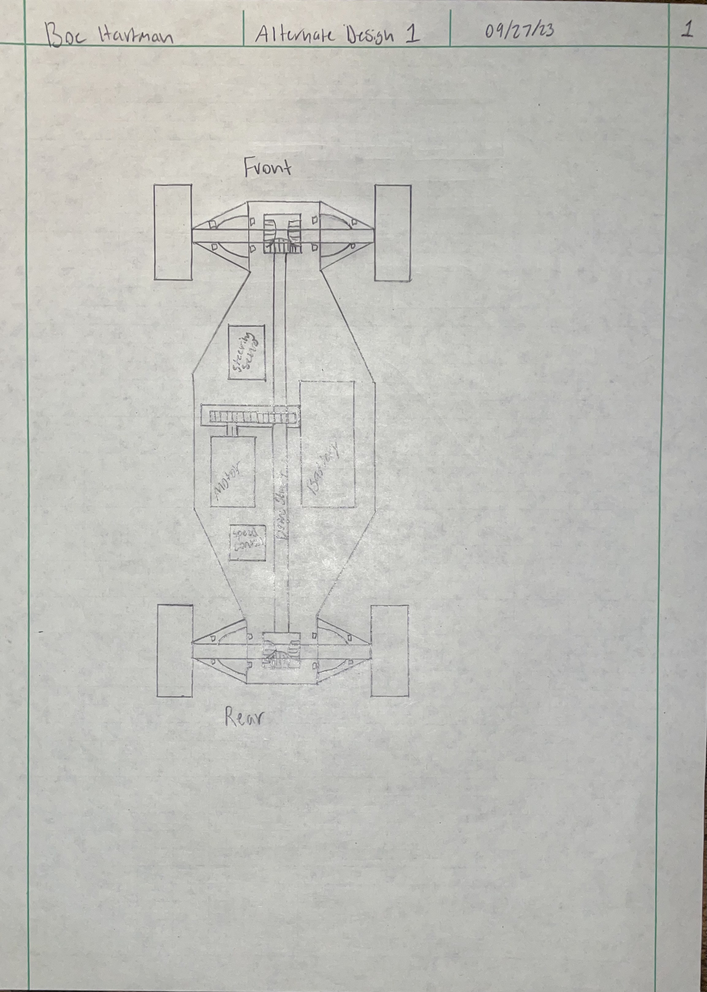
The design for the chassis is based on a traditional trophy truck fame structure but instead incorporating AWD with an all-around independent suspension. The independent suspension components bolt directly onto the frame. The motor and all other electronics will be fitted around the drive shaft that runs through the center of the chassis. The power from the motor will be transferred to a two-way straight driveshaft using two spur gears one from the motor driving the other attached to the driveshaft. The driveshaft then transfers the power to the front and the rear of the RC Baja car. The power at the front and rear of the vehicle will be transferred into a gear box on both sides that houses three bevel gears. The power will be transferred through those gears into the CV axles and to the tires on the ground. An initial design sketch can be found below in Image 2.1.
Image 2.1 – Initial design sketch with inspiration from F1 Car and Trophy Truck chassis.

c. Benchmark

The benchmark chosen for this project was the Traxxas Rustler RC car. The Rustler was chosen as the benchmark for this project because the overall chassis shape is very similar to the design of the RC Baja car. It also contains a very similar drivetrain which incorporates an AWD system. The drivetrain also uses a single driveshaft that spans the length of the chassis to transfer power just like the RC Baja car. This is an RC car that is readily available and affordable for commercial use.

d. Performance Predictions

The RC Baja car will be able to complete all three challenges. The Baja, drag race, and Solemn time trial. The chassis will weigh less than 10 pounds and be able to accelerate from 0 – 15 mph in less than 5 seconds.

e. Description of Analysis

The required analysis will determine what size driveshafts and CV axles to use in order to withstand torque outputs of an electric motor using statics, basic electricity equations, and mechanical design. Analysis is performed on the chassis of the vehicle using statics and dynamics to ensure proper support of all components while maintaining a lightweight rigid design. Along with the required motor output power and gear ratios required to meet performance requirements listed in section 1.d.

f. Scope of Testing and Evaluation

The testing and evaluation of the RC Baja car will be conducted and based on the requirements listed in section 1.d. The two main requirements for testing will be top speed and durability. The speed test will be set up similar to the drag race. Rolling into start testing and from dead stop testing. Along with drop testing and bump testing to ensure the vehicle could withstand similar effects to that of the Baja competition. This will be tested by dropping the full vehicle from four feet in the air.

g. Analysis

I. Analysis 01 – Power Required to Accelerate Vehicle

Analysis 1 consisted of power and acceleration equations using dynamics which analyzed the required output power needed by the motor to meet the speed requirement of 15 mph within 5 seconds. Stated in section 1.d.15. A design factor of 1.5 was used in order to push the limits of the requirements. The analysis resulted in the minimum power requirement to achieve 22.5 mph (speed including design factor) in 5 seconds to be 138 Watts. This is good because the power provided by the motor is 190 Watts. The analysis calculation sheet is located in Appendix A01.

II. Analysis 02 – RPM, Gear Ratio, Required Torque

Analysis 2 analyzed the gear ratios that are necessary within the drivetrain using unit conversions, circumference, RPM and torque equations used in mechanical design and mechanics of materials. This was done to achieve the gear ratios which are needed to know the required torque of the axles to the output torque of the motor. This is necessary to the requirement stated in section 1.d.15 requiring 15mph with a design factor of 1.5 which needs 3.94 lb-in to achieve this speed in a 9 lb vehicle. The calculated torque output of the motor is 6.172 lb-in in the axle. The analysis calculation sheet is located in Appendix A02.

III. Analysis 03 – Minimum Chassis Thickness

Analysis 3 analyzed the necessary thickness for the chassis using mechanics of materials and statics with a deflection of 5/16 inch per requirements listed in section 1.d.11, under 18 lbs of load. From the analysis in Appendix A03, the calculated minimum required thickness is 0.325 inches using PLA+. Since 0.35 inches is a nominal value that is easy to keep track of while 3d printing and is greater than the required 0.325 in. The drawing of the associated part is in Appendix B07.

IV. Analysis 04 – Central Driveshaft Diameter

Analysis 4 analyzed the necessary diameter of the central driveshaft required to sustain the applied torque of the motor to move the vehicle using mechanics of materials. This was calculated in Appendix A04 per the requirement stated in section 1.d.16. Using the max yield strength of the aluminum, and back solving for the minimum diameter with regards to the applied torque. This was found to be 0.044 inches. Since this is so small, for ease of manufacturing, adding to rigidity, and readily available a size of 0.25-inch diameter aluminum will be used for the central driveshaft. The drawing of the associated part is in Appendix B05.

V. Analysis 05 – CV Axle Diameter

Analysis 5 analyzed the required diameter for the CV axles being used in the device using mechanics of materials. This was calculated in Appendix A05 per the requirement stated in section 1.d.16 and 1.d.1. This was done the same way the required diameter was calculated for the central driveshaft. Using the max yield strength of aluminum, and back solving for the minimum diameter with regards to the applied torque. This was found to be 0.044 inches. Since this is so small, for ease of manufacturing, adding to rigidity, and readily available a size of 0.25-inch diameter aluminum will be used for the central driveshaft. The shear force and deflection were calculated to ensure the diameter of 0.25 is sufficient. The shear force applied is only 45.8 psi while the yield strength of the material is 40,000 psi.

VI. Analysis 06 – Tire size/Diameter

Analysis 6 analyzed the required tire size diameter using dynamics equations. This is necessary to the requirement stated in section 1.d.15 requiring 22.5mph. The calculations supporting this analysis can be found in Appendix A06. This was calculated using the gear ratio of 10:1 with a max RPM of 25,000 and a velocity of 22.5 mph. The calculated minimum tire size diameter was found to be 2.96 in. This is ideal as the team wants to use 4 in diameter tires for more ground clearance. With a diameter of 2.96 in the device would not be capable of achieving more than 22.5 mph with the currently selected motor therefor the larger tire size is more ideal.

VII. Analysis 07 – Motor Mount Thickness

Analysis 7 analyzed the required thickness for the motor mount that could withstand the output torque of the motor using mechanics of materials. This is necessary to the requirement stated in section 1.d.16 requiring all components to support torque output of motor necessary to achieve 22.5mph. The calculations supporting this analysis can be found in Appendix A07. This was calculated using the max stress of the material and the moment created by the torque to back solve for the thickness. This was accomplished using a stress concentration factor of 3.5, a max stress of 10,878 psi for PLA+ plastic, a torque output or moment of 6.172 lb-in. The required thickness calculated was 0.138 inches. A thickness of 0.25 inches will be used for ease of manufacturing and only increasing the structural integrity of the component. The associated part can be found in Appendix B08.

VIII. Analysis 08 – Rear Axle Diameter

Analysis 8 analyzed the required diameter of the rear axle encased in the diff using mechanics of materials. This component transfers motion from the central driveshaft to the CV axles using a Bevel and Ring gear. This is necessary to the requirement stated in section 1.d.15 requiring 22.5mph. The calculations supporting this analysis can be found in Appendix A08. This was calculated using the max yield strength of aluminum, and back solving for the minimum diameter with regards to the applied torque of 6.172 lb-in. This was found to be 0.1853 inches. For ease of manufacturing, adding to rigidity, and readily available a size of 0.25-inch diameter aluminum will be used for the rear axle. The drawing for the associated part can be found in Appendix B09.

IX. Analysis 09 – Bending & Shear stress, 4 ft Drop

Analysis 9 analyzed the bending and shear stress of the chassis when a four-foot drop is applied using statics and mechanics of material equations. This was done in respect to the requirement specified in section 1.d.2. The calculations supporting this analysis can be found in Appendix A09. After determining the deflection using a weight of 18lbs (the weight of the vehicle using a safety factor of 3 to be 0.25 inches. This was used to determine the impact factor of the four-foot drop which was found to be 20. The yield strength of PLA+ is 10,878psi and the calculated bending stress was found to be 9,362 psi. Which is less than the yield strength of PLA+. The calculated shear stress was found to be 84.6 psi which is less than the ultimate shear stress of PLA+ of 4,714 psi. Since both the shear stress and bending stress are less than the ultimate shear stress and yield strength of PLA+ the dimensions chosen for the chassis are sufficient and it will not break from a four-foot drop. The associated part can be found in Appendix B07.

X. Analysis 10 – Thickness of Lower Diff Connecting Pin

Analysis 10 analyzed the thickness of the connecting pin being used to secure the control arms to the lower differential cover/chassis using statics and mechanics of materials. This was calculated in Appendix A10 to ensure the diameter of 0.125in using aluminum would not break. Using Equilibrium beam analysis and solving for the max moment. Which was then used to solve for the stress in the pin; 28,162 psi which is less than the yield strength of 40,000 for 6061-T6 Aluminum. After determining the stress, the rod would experience being less than the yield strength the shear stress was then determined to be 244.5 psi which is less than the shear strength of aluminum to be 30,000 psi. Therefor the rod should not break under an 18 lb load (safety factor of three for 6 lb vehicle). This satisfies the requirement in section 1.d.18 stating components must support the weight of the vehicle with a minimum safety factor of 2. The associated part is in Appendix B06.

XI. Analysis 11 – Connecting Bolt Shear Stress Analysis

Analysis 11 analyzed the shear stress being applied on the bolts connecting components to the chassis using statics and mechanics of materials. This was calculated in Appendix A11, using an assumed force of 20 lbs being pulled in each direction using M3 bolts with a minimum diameter of 0.21 in. The shear force found in the bolt is 577.4 psi. The max shear strength is 40,000 psi. Therefor the bolts should more than suffice. More than one bolt will be in use as well. This fulfils requirement 1.d.12, all components must be able to resist 10 lbs force on any given component.

XII. Analysis 12 – Thickness of Upper Diff Connecting Pin

Analysis 12 analyzed the thickness of the connecting pin used to secure the control arms to the upper differential cover/chassis. This analysis, outlined in Appendix A12, was conducted to ensure that using aluminum with a 0.125-inch diameter would not result in failure. Using Equilibrium beam analysis and solving for the maximum moment, which was used to find the stress in the pin from statics and mechanics of materials. This was calculated to be 28,162 psi, well below the 40,000 psi yield strength of 6061-T6 Aluminum. After establishing that the stress in the rod is below the yield strength, the shear stress was determined to be 244.5 psi, which is lower than the shear strength of aluminum at 30,000 psi. Consequently, the rod is expected to withstand an 18 lb load (with a safety factor of three for a 6 lb vehicle) without breaking. This analysis satisfies the requirement set forth in section 1.d.18, stating that components must support the vehicle's weight with a minimum safety factor of 2. The associated part is in Appendix B06.

Device : Parts, Shapes, and Conformation

The overall shape of the chassis was chosen due to the requirements in section 1d. This design encompassing a “shell” over the crucial drivetrain components provides ergonomic support in the sense of efficient assembly and deconstruction of the vehicle if necessary. From that section the necessity of having an AWD system heavily influenced the overall shape of the chassis. Stemming from an independent suspension chassis similar to an F1 car meshed with a trophy truck. This will provide adequate clearance and travel with enough room for a CV axel AWD system. The structure of the chassis will have a design factor of 1.5 to ensure unforeseen loads that may be applied during the three challenges. This will provide structural strength and rigidity to the chassis. Design and Safety factors are used in the analysis and design of the gearing components and driveshaft and CV axles. The safety factor consists of 2 for all drivetrain components. This will ensure that if more power is applied to the vehicle, it can withstand the power increase and with that increase in torque as well. As well as functionality and maneuverability of the RC Baja Car. A tolerance of 5% is in place for centering the central driveshaft to ensure power is applied to all four wheel evenly so no wandering takes place driving the vehicle in a straight line.

Device Assembly

The RC Baja Car is built to ensure that all requirements stated in section 1d are complied with. Along with the ability to compete and perform well in the ASME RC Baja car competition. The drivetrain consists of a motor with an output shaft feeding a primary gear box transferring power to a central drive shaft. All three components are to be mounted to the central section of the chassis. From the central driveshaft the power is applied to two secondary gear boxes located at the front and rear of the chassis. From there the power is applied to the CV axles mounted to the steering knuckle and to the tires to the ground providing motion to the vehicle. The chassis consists of one solid bottom plate of 1/8’’ thick aluminum with side rails bent up to assist in mounting and rigidity. The chassis provides support and mounting for all drivetrain components along with mounting for suspension and steering components.

j. Technical Risk Analysis

Some technical risk associated with the RC Baja car will be durability and speed. In order to achieve a significant speed above 15 mph this will require the RC Baja car to be as light as possible. This will be achieved by using as many 3D printed plastic components as possible in areas where minimal stress and strain is applied. However, this is where technical risk comes in, the necessity for a lightweight rigid design. As parts become lighter or smaller the rigidity of the component and the material itself may begin to fall to low. Analysis will be done to ensure the components that are 3D printed are rigid and durable enough to support the design.

k. Failure Mode Analysis

The RC Baja car consist of many forms of failure mode. When the RC Baja car is in motion there are Dynamic forces taking place on the vehicle, torque within the driveshaft and CV axles. The diameter of the driveshaft and CV axles will be determined based on the max torque the axles and shaft will experience. The chassis must also support upward forces from the attached suspension and steering members as the vehicle experiences bumps or rough terrain. The material thickness and dimensions of the chassis can be determined from static equilibrium forces and using deflection of the material. There is also the possibility of overheating the battery or the motor. The 3D printed components though should not experience much load will fail in a brittle fashion if proper analysis for dimensions does not take place. To mitigate brittle fracture the only components experiencing minimal load or forces will be 3D printed. Fatigue failure from repetitive load being applied on the drivetrain components. Impact failure will occur if the vehicle hits an object of a larger mass.

l. Operation Limits and Safety

The operation limits and safety associated with the RC Baja car project include mechanical and electrical risk. The mechanical risk stems from all of the moving components within the vehicle that could easily snag a finger or piece clothing. This will be mitigated by encasing all gears in gear boxes and only leaving axles and driveshaft exposed. The electrical risk stems from the battery and associated wiring to the motor. The battery can become a risk if punctured or wired incorrectly. All wires will be thoroughly connected and protected using heat shrink. The battery will be stored in a protective box within the chassis to prevent a puncture.

3. METHODS & CONSTRUCTION

a. Methods

The decisions made for this project, the processes, the supporting analysis, design, and manufacturing are all done within CWU and between the two teammates houses. Between these two resources the main forms of manufacturing available are CNC machining, hand machining, many forms of fabrication, and 3D printing. Due to these constraints the design process has kept in mind what forms of manufacturing are easily available and will provide the most efficient and ease of manufacturing. As there is some complexity in some components this can lead to complications while manufacturing.

i. Process Decisions

Throughout the process of construction a few forms of manufacturing will be used. This will include hand machining being done on the lathes and vertical mills. Along with 3D printing and plastic molding and casting.

The chassis of the vehicle will be 3D printed as this is the lightweight, cheapest, and easiest to manufacture material. This decision was made based on the design matrix within Appendix F02. To verify/support this decision multiple analysis were performed in Appendix A03 and A09 to determined that a chassis thickness of 0.4in using PLA+ as stated in section 2.g.III and 2.g.IX will more than surpass the requirement listed in section 1.d.2. that the car will surpass a four-foot drop. Per requirement 1.d.11 the chassis must not deflect more than 5/16 of an inch. Using a lightweight material that is easy to manufacture such as PLA+ while still meeting the requirements is ideal for the project.

The chassis of the vehicle will be manufactured using a 3D Printer. This decision was chosen based on the decision matrix within Appendix F03. Within the decision matrix the decisions that held the most weight were ease of manufacturing, time, and cost. As 3D printing is very useful for complex structures that are difficult to machine with a CNC let alone by hand that is why this was ranked highest for ease of manufacturing. This falls right into the next section time. Time is very valuable within the project and in general, it can be very time consuming for machined parts whereas with a 3D printer the ability to start a print and walk away from it is much more efficient and less time consuming. The cost of machining a part coincides with the time it takes to manufacture, and the materials being used in the manufacturing process. The cost of machining or casting aluminum is much more expensive than 3D printing with plastic. The cost for one roll of PLA+ to 3D print all the chassis’ components is less than $30 whereas the cost of a plate of aluminum and man hours required to machine one component would be well over $200.

The drivetrain of the vehicle will be manufactured using vertical mills. This decision was chosen based on the decision matrix within Appendix F04. Within the decision matrix there were three heavy weighted decisions such as strength, ease of manufacturing, and size. The strength of the drivetrain components is very important as these will provide motion for the vehicle. These parts cannot cripple under their own power and cannot fail under various forms of impact during use. The drivetrain consists of the central driveshaft and axles. These parts cannot be made using a 3D printer as the parts produced will be too weak to support the motion of the vehicle. Though 3D printing would be much more time efficient and provide more ease of manufacturing the strength of the material is far more important. 3D printing could work if the diameter of the driveshaft and axles were large enough however finding gearing and the weight associated with the larger diameter would become difficult. The strength provided by using a vertical mill with aluminum is far superior to 3D printing filament. The ease of manufacturing might be greater than 3D printing but is much less time consuming to casting. The size of the rod milling out keyways on aluminum is much thinner than 3D printing and similar in weight.

After further reconsideration and in light of newfound materials students are now able to cast a thermoset plastic. In order to cast a thermoset plastic a 3D printed mold will need to be created. Therefor utilizing the previously stated and designed chassis to create the mold for the thermoset plastic cast. The thermoset plastic is provided by CWU with no cost to students. Testing with sample specimen was done using ASTM D638 to ensure that the strength of the thermoset plastic is stronger than that of 3D printed PLA+. Once testing is complete and the students’ predictions have been proven to be true, a thermoset plastic will be used to cast the chassis. Not only is a thermoset plastic predicted to be stronger than PLA+ it will be a much lighter component due to the strength associated with the original chassis thickness which can now be lowered using a thermoset plastic. The thermoset plastic is much easier to add threaded inserts as the material will not alter unless under extreme heat. Whereas when drilling or heating PLA+ this greatly alters the material as it is formed using lower temperatures than that of the thermoset plastic can withstand. Especially when adding threaded inserts. As one screw up could lead to an entire reprint. As testing is accomplished and the predictions of the newfound material have been proven right or wrong. A decision matrix was used to form an unbiased opinion to ensure the thermoset plastic is ideal choice of material for the chassis. This can be found in Appendix F03 detailing the breakdown and decisions as to why a thermoset plastic was chosen.

An additional change in the manufacturing process that occurred during part construction was the material used for the central driveshaft. While manufacturing the central driveshaft the original chosen material was 0.25” aluminum this found to leave too thin of a gap between the ID and OD where the pinion gear fits in. Due to this small gap and the heat associated with drilling while trying to drill into the ends to create the press fit hole the aluminum began to experience warping and bending. This was overcome by increasing the OD to 0.425” which in turn increased the gap between the OD and the ID of the hole. A material change was also made from aluminum to steel which assisted in keeping the material from warping or bending during the drilling process of manufacturing. Though this added additional weight to the RC Baja Car this was not a major issue as when selecting the motor and ESC a safety factor was in place to ensure there is enough torque and power necessary to move the car and for the chassis to maintain structural integrity even if the team exceeds the original design weight of the vehicle. Though this material change took place the manufacturing process did not change. The associated decision matrix describing the manufacturing process can be found in Appendix F04.

b. Construction

i. Description

The RC Baja car will be made up of three subassemblies of a combined 28 parts not including fasteners. All but eight parts will be manufactured here at CWU. Eight parts are being purchased which include gears or electrical components along with some suspension components. Another ten parts will be created by team member Jarvis Hudnall who is working on the suspension and steering components. The other ten parts will be manufactured by Boe. The first subassemblies are divided up by sections of the vehicle, from the front section to the center section and lastly the rear section. This assemblies will be made up of parts from both team members. The front section assembly will be thought of as phase one of construction along with center section assembly as phase two of construction and rear section assembly as phase three of construction.

ii. Drawing Tree, Drawing ID’s

The drawing tree hierarchy is made up of three major subassemblies to complete the project. This is shown pictorially in Appendix B1. The front section assembly will consist of suspension components such as control arms, push rods, and steering knuckles. Along with drivetrain and chassis components such as front axle, CV axles, bearings, and bevel gears. The center section assembly will consist mostly of purchase parts such as the motor, battery, Esc/receiver, and spur gears. This will also include manufactured components such as the chassis, center channel, central driveshaft/supporting structures, and motor mount. The rear section assembly will be identical to the front section assembly but for construction purposes it will be broken up into these three section assemblies.

iii. Parts

Fall:
This project consists of three process groups. Including purchased parts, modified purchased parts, and manufactured part. Purchased parts include those in Appendix C such as the Motor, Battery, and Gears. Modified purchased parts will be machined using the vertical mill and lathes for creating keyways and shaving down the central driveshaft 1/10’’ for the bevel gear to fit. This will be purchased ¼” aluminum rod stock. This is shown in Appendix B01, and a similar process will take place for the axles (BEH-20-005). Manufactured parts will be 3D printed using CWU 3D printers and at home 3D printers. This will include parts such as the chassis (BEH-20-002) and the Differential covers (BEH-20-006 & BEH-20-007).

Winter:
Throughout the winter quarter several part changes occurred. These include, the Central Driveshaft (BEH-20-001) and the Main Chassis (BEH-20-003), though the overall shape and dimensions of the chassis have not changed a material change took place going from PLA to 65D thermoset plastic. Originally the battery was to be velcroed to the chassis however, the team has now produced battery mounts that will fix the battery to the chassis in a sturdier manner, while still incorporating the velcro straps, Battery Mount (BEH-20-015). In addition to these part changes, several parts were designed and manufactured for material testing during winter quarter. These include, Test Sample (BEH-20-011), Test Sample Mold (BEH-20-012), Chassis Mold (BEH-20-013), and Bumper Mold (BEH-20-014). These reflective changes are shown in the parts list associated, located in Appendix C Parts List.

iv. Manufacturing Issues

Fall:
Potential risks associated with manufacturing include machine breakdown. This could include 3D printer nozzle becoming clogged or potential software issues that keep the 3D prints from being performed in turn delaying the project. This could also occur in vertical mills or lathes. If a pulley or belt breaks this could leave downtime on the machines delaying the project. If there is an unforeseen shortage of aluminum, there could be difficulties securing aluminum rod stock, however this is a highly unlikely scenario.

Winter:
During the Fall quarter the team accurately predicted risk associated with the chosen manufacturing processes. This included issues with the 3D printers. Specifically issues with clogging nozzles and calibration issues not only with the teams at home printers but also those within CWU. This was quite troublesome as a majority of the parts associated with this project were 3D printed. This led to a delay in the manufacturing process and for new ideas or processes for manufacturing. This was a lot of the reasoning for switching from a 3D printed chassis to a cast plastic chassis. As this would save the team and CWU a lot of PLA+ filament and downtime waiting for the 3D printers to print. This also strayed away from the need of 3D printing which in turn decreased the risk associated with 3D printing. Aside from 3D printing issues, there were additional manufacturing issues associated with the Central Driveshaft (BEH-20-001). This occurred while drilling the end holes for the pinion gear to be press fit and pinned in. While manufacturing, the aluminum began to warp during drilling which caused the Central Driveshaft (BEH-20-001) to no longer be straight. This would greatly affect the driving ability of the RC Baja Car as this supplies power from the motor to the axles. Though this issue was not associated with the lathe in use itself but rather the material and size chosen. This was overcome by switching from aluminum to steel and increasing the overall OD of the Central Driveshaft (BEH-20-001).

v. Discussion of Assembly
The RC Baja Car is assembled in three sections/assemblies. This includes the Front sub-assembly which will be assembled in this order and consists of the Diff Pins (BEH-20-002) which are used to fasten the control arms to the Upper and Lower Diff covers (BEH-20-006 and BEH-20-007). The Upper and Lower Diff covers house the Axle (BEH-20-005) which is fixed to the Axle Bevel Gear (BEH-55-001). Serving as a mounting part for additional components the Upper and Lower Diff covers secure the Bumper (BEH-20-010) and Bumper Spacer (BEH-20-009) to the RC Baja Car. This is the first assembly/section of the RC Baja Car to be assembled. As the RC Baja Car is 4wd the team utilized the exact same assembly in the rear, referred to as the Rear sub-assembly which will be assembled in the same fashion as the Front sub-assembly utilizing identical parts/components. After both the Front and Rear sub-assemblies are assembled the assembly of the Center sub-assembly will take place. This will be assembled in this order and consists of the Central Driveshaft (BEH-20-001) which is pinned and pressed onto the Driveshaft Bevel Gears (BEH-55-007) on both ends of the Central Driveshaft. Along with a keyway and Driveshaft Spur Gear (BEH-55-006) fixed in the center of the Central Driveshaft. The Central Driveshaft will be secured to the Main Chassis (BEH-20-003) through the Central Driveshaft Bearing Mounts (BEH-20-008) which allows for rotation of the Central Driveshaft while driving the RC Baja Car. In addition to these components, the Motor Mount (BEH-20-004) will be fixed to the Main Chassis which acts as a mount for the Motor (BEH-55-002) that will be attached to the Motor Spur Gear (BEH-55-005) that drives the Driveshaft Spur Gear. Following the Motor and Motor Mount the ESC (BEH-55-004) will be fixed to the Main Chassis along with the Battery Mounts (BEH-20-015) which act as a mounting point for the Battery (BEH-55-003). This is conveniently organized both in the Drawing Tree in Appendix B01 and the Parts List in Appendix C. In terms of final assembly of all components in the RC Baja Car meet all size and cost requirements listed in section 1.d. This will provide and result in a 4wd RC Car that is capable of achieving a minimum of 15 MPH in 5 seconds as listed in the requirements section 1.d.14. This is an accurate representation of the benchmark RC Car device chosen, the Traxxas Rustler RC Car.

4. TESTING

Introduction

The testing done on the RC Baja Car will be done to ensure all requirements listed above in section 1.d are fulfilled. There will be four tests for drivetrain and chassis that highlight three major requirements but fulfill the rest in the meantime. The first test will be an acceleration test to ensure requirement 1.d.15 is met. This requirement states that the vehicle must accelerate to 15mph in 5 seconds. The group predicts this requirement will be met as the analysis for the power output of the motor and the gear ratio is more than enough required to accelerate the vehicle. The second test will be a jump/drop test to ensure the requirement of 1.d.12 is met and or exceeded. The group predicts the car will exceed well over a 10lb drop test due to each component being manufactured to exceed two times the required load. The third test will be a crash test. This will be oriented towards requirement 1.d.17 stating the RC Car must be able to support an impact/crash at a minimum of 22.5mph. Based on the analysis done on the components of the vehicle the team predicts the car will survive and exceed the crash test. The fourth test will be a dimensions and weight test. This will be done to make sure that requirements like 1.d.2, 1.d.3, and 1.d.13. Based on the dimensions and material selection used for components during design the team predicts the vehicle will surpass this test with ease.

Method/Approach

As stated above there will be four tests consisting of acceleration testing, jump/drop testing, material testing, chassis testing, and dimension/weight testing. Each test will be repeated five times and analyzed after each test to ensure that adjustments can be made for improvements for the next test. Additional testing will be done as needed or if testing is not complete due to component failure.

Acceleration Testing: This will be accomplished by setting up a set distance of 20 feet and driving the RC car at full speed while recording the distance traveled using the pre-determined distance and the time it took to get there using a stopwatch and recording. With this information students will be able to determine the speed and acceleration of the vehicle. Changes like switching out spur gears to increase or decrease the gear ratio can be made during testing to improve results.

Jump/Drop Testing: Drop and jump testing will be accomplished by simply dropping the vehicle from 4 feet. And analysis the results of the impact on all the components within the vehicle. The jump test will be in the same fashion in the sense the vehicle will be jumped off a wooden ramp donated by Boe’s parents, 4 feet off the ground with a speed of roughly 10 mph.

Chassis Testing: This testing will be accomplished by setting up the chassis within the Instron and applying a load greater than 18 lbs in order to determine if the chosen material thickness will suffice the 18 lbs load with less than 5/16-inch deflection.

Material Testing: Material testing is done to ensure the proper material is chosen in order to support the chassis of the vehicle. This is accomplished through Instron testing ASTM D638 standard size 65D test samples.

After completion of testing, it was prominent the data collected must be displayed in an orderly fashion. Doing so which not stated above was done through excel as the data is provided from the Instron within excel. Testing was much more rigorous and long for the material testing than originally predicted. Through the various samples and composites which ended up being used rather than the singular 65D thermoset plastic. This was simply resolved through preservation and determination testing every available composite type within CWU. During chassis testing all went very smoothly and the chosen material PLA+ proved to work far better than expected and calculated surpassing the requirements set to be fulfilled.

c. Test Process

The acceleration and speed test process are done by using a flat smooth surface with little bumps but enough traction for the RC Baja Car to hook up. Ideally this surface will be a concrete or asphalt surface with some texture to allow for proper friction between the tires and the concrete or asphalt. This is a simple test that consists of five runs that will be logged, and the average will be taken to ensure the RC Baja Car meets the specified speed and acceleration requirements.

The jump and drop test are accomplished very literally. By jumping the RC Baja Car off a jump and dropping the RC Baja Car by a prescribed height. This test ensures that the RC Baja Car meets the specified requirements. Which are in place so the vehicle won’t break during the RC Baja course being there will be jumps and drop offs. Similarly to the acceleration and speed test, five drops and jumps will be done but rather than being recorded the vehicle will be inspected to ensure no deformation or breakage occurs during the jumps and drops. However, this test will need more space as a jump will need to be in place with enough room and height to jump and drop the vehicle.

The crash test is quite literal as well. A sturdy wall is necessary to repetitively ram the RC Baja Car into. Similarly to the jump and drop test, five crashes will suffice. After each crash the vehicle will be inspected for any deformation or breakage. Specifically, the bumper, bumper spacers, upper and lower diff covers will be inspected as these are the main components that will be absorbing the force from impact. This test will determine if the vehicle can withstand the crashes to meet the specified requirements.

Dimension and weight testing is the shortest of all the tests and requires the least amount of space. Simply by measuring the vehicle and weighing the vehicle the team can determine if the RC Baja Car meets the specified dimension and weight requirements. This is crucial as the motor, ESC, and gear train have been chosen based on the weight requirements of the vehicle. A singular weight and dimension measurement will suffice as this will not change unless the vehicle does not meet the specified requirements.

d. Deliverables

All forms of testing will be compiled into a singular spreadsheet that will contain multiple sheets within for each form of testing. Each form of testing within the spreadsheet will have all of the associated pictures of and during the test alongside the tables of the recorded data. This adds to the ease of understanding of the testing when viewing the testing spreadsheet.

The first sheet will contain the acceleration and speed test data. For each run the distance is to be noted even though this is fixed but the time taken to arrive at the set distance will be recorded five times. Each run will be recorded into a table on the first sheet.

The second sheet contains data from the jump and drop test. Since the height of the jump is fixed this will be noted along with the angle and length of the jump. As this is not necessary for proof of requirements/analysis this will be nice to note and good data to have. Each jump will be recorded into its own table describing the behavior of the vehicle but also description of any deformation or breakage of the vehicle. Next to this table is the drop test table which notes the fixed height of the drop while recording and taking notes of any deformation or breakage of the vehicle during those drops.

The third sheet contains the test data from the crash test. Similar to the jump and drop test a table will be made describing the wall/barrier that will be used for crashing the vehicle into. The distance from the start, the time it took to get there, and the deformation or breakage of the vehicle will be recorded into the table for each run during this test.

The fourth sheet contains dimension and weight testing. Though this is a simple test the dimensions and weight will be recorded into a small table. This is important as if any last-minute changes occur the team will be able to differentiate the difference in weight before and after ensuring the team meets the previously specified requirements.

The use of the material testing is to determine if 65D is a good material to use for the chassis of the RC Baja Car. This is determined by finding the force vs displacement to determine the young’s modulus value. Per requirement 1.d.11 the chassis must not deflect more than 5/16’’. In order to find the thickness required to produce a deflection less than 5/16” the three-point load deflection equation was rearranged to solve for height (thickness). Since each other value within the equation is constant the determining value is the young’s modulus of the material in use. When using PLA+ the young’s modulus is equivalent to roughly 304,000 psi which after plugging this value into the equation produces a thickness of .35in. After testing with the 65D material the average max young’s modulus between each of the trails was found to be roughly 400psi. As this is a much lower value the thickness of the chassis was found to be much thicker. In turn the calculate thickness of the chassis was found to be 3.3in using 65D. As this is far to thick to realistically be used on the RC Baja Car, PLA+ is used as this produces a thickness of .35in. Some issues that took place during testing were a small variation between test sample size as this would affect the area which in turn affects the young’s modulus by either increasing or decreasing the stress the test samples experience. This was mitigated by performing multiple tests as this provides a larger sample which reduces the likely hood of sampling errors.

5. BUDGET

Parts

The parts that will need to be order will come from various websites including Amazon, eBay, HobbyKing and more. The parts list depicts the seller description and manufacture part number listed below in Appendix C. The bare stock materials will be supplied by CWU Machine Shop such as the material used in part BEH-20-002. All part associated cost and description can be found in Appendix C. Fasteners and hardware will be purchased and priced using McMaster Carr however, some of the hardware will be sourced through CWU. An example of the hardware is BEH-50-001 which can be found in Appendix C.

The parts being purchased for the Drivetrain and Chassis is estimated to be $300 this is chosen with a small amount of room for unforeseen circumstances like shipping fees, parts breaking and needing replacements, or design changes that may be necessary throughout the project.

Outsourcing

Some parts used within the project will be send out to external manufacturers such as Send-Cut-Send. One of the components being sent to send cut send is BEH-20-005 the axle. However, as many parts as possible will be manufactured/machined in house at CWU. The allocated budget for external manufacturing can be found in Appendix D with a cost of $150 quoted form send cut send.

Labor

The labor cost associated with the project is estimated using the industry standard wage of an entry level engineer being approximately $40 an hour. With approximately 100 hours of labor, the estimated total labor cost for this project is $4000. This can be found in Appendix D.

Estimated Total Project Cost

The estimated total project cost includes sub totals from labor, material, purchased, parts, and manufacturing. Labor costs are highlighted in 5.c. for a sub total of $4000. While this cost is considered, labor has been donated by students working on the project and doing manufacturing in house. The total material cost of the project is estimated to be $50. This is used to purchase bare stock materials that will be manufactured by students in house. Purchased parts cost are $243, this includes all premade components such as the motor. Some parts will also be outsourced for manufacturing. The total cost for manufacturing is $150. The project is also subject to contingency funding as unforeseen costs could arise. The estimated total project cost including labor donated by students is $4608. The estimated total project cost excluding labor donated by students is $608.

Funding Source

The funding source for this project comes from CWU in the case of materials that will be used in house. However, the remainder will come from the two team members, Boe Hartman and Jarvis Hudnall. As the project is split between two focuses Drivetrain Chassis and Suspension Steering. The total cost of the two focuses will be added together and split evenly between the two team members.

f. Winter Updates

5a: Throughout winter quarter there have been several small changes to the cost of the project. These changes are mainly due to a change in the manufacturing process. Due to this change, there is no longer a need to use send cut send. Instead, the manufacturing will be done at CWU. This will reduce cost of the project by approximately $150 based on the quote obtained from send cut send. Though this decreased the cost of the project, a different motor and ESC has been implemented causing an increase in price. This increase in price is still smaller than the amount saved from manufacturing changes. The previous motor and ESC chosen price was $90, the new motor and ESC cost $205 after shipping. Leaving a surplus of $115 saved overall since the start of the project.

5b: Fortunately, throughout the design and development of the RC Baja Car project the team strived to manufacture as much as possible in house. At first to ensure completion of the project the team planned to utilize send cut send. However, it was found that the parts going to be sent to send cut send can be manufactured in house at CWU. Since this is the case, the axles will no longer be sent to send cut send and there will be no issues with outsourcing. This in turn also saved the group a total of $150. Some shipping delays occurred in the delivery of the CV Axles. This is not crucial as the CV Axles still arrived sooner than necessary to assemble the RC Baja Car. This also had no overall affect on the cost/budget of the project.

5c: Though the future engineers involved in this project time is considered free, the cost of the time associated is still considered as a cost to the project at the rate of an entry level engineer. Thankfully the team over predicted the time associated to complete the project. Due to the manufacturing process changes and change in material used for the chassis, this added additional time to the manufacturing process and therefor more cost in time. With the over predicted time to cost or labor the team predicated this had no overall effect on the cost of labor. The time associated can be found within the schedule in Appendix E. Which greatly shows the over predicated time in labor the group made at the start of the project.

g. Spring Updates

6. SCHEDULE

Design

Fall:

Following the schedule listed below for reference in Appendix E. The three main sections for fall can be divided up by section one Proposal/Report writing, section two Analysis, and section three Documentation. Each section has its own tasks associated with it which must be completed in a sequential order in order to ensure proper completion of the project. At the beginning of the project group members overestimated the time on task needed for the section one and two by 16 hours. This actually worked out for the better as the necessary predicated time for section three fell short in turn allowing for the excess time in sections one and two to roll over into section three. This time will be useful during winter quarter. Winter quarter consist of manufacturing and construction. As often as shipping delays and other risks associated with delaying the project this additional 16 hours saved during fall quarter will be quite useful.

Winter:

As shown in the Gantt Chart listed in Appendix E. Due to the team’s decision to switch from using PLA+ to 65D thermoset plastic, this set the team back approximately 8 hours due to the need for PLA molds for the components experiencing this material change such as the chassis and bumpers. Thankfully the initial design using the PLA+ was still crucial to the design of the molds and therefor not a waste when switching materials in anyway. The reflected time is shown in section three Documentation, Task 3m. Additionally due to the material change this allowed for the team to incorporate additional components that would have been separately mounted to the chassis that are now a part of the chassis creating overall less parts for the team to manufacture. In fall quarter the team was ahead of schedule 16 hours due to large predictions of allocated time, due to the upfront unpredicted time necessary for the material change and the time saved from incorporating additional parts into one on the chassis, the team is still ahead of schedule by approximately 6 hours.

Construction

Fall:

Physical construction of the RC Baja Car will take place in winter quarter but the digital construction including part designs and assemblies are completed in fall quarter when Analysis and Documentation begin as shown in the schedule in Appendix E. During part design and assembly issues lied within taking an idea or concept to then constructing drawings that can be easily repeatable by any manufacturer. For example, while creating the chassis using PLA+ it was notable this would be difficult to fit within the printing bed dimensions to print as one solid part. This was difficult to work around in order to determine the best way to manufacture the part. This will be accomplished by printing the chassis as a two-piece part to be secured together by a suspension mounting channel. The best way to manage issues of this nature is to work ahead of schedule and cut down as much time possible on other tasks to stay on track.

Winter:

As per the schedule below in Appendix E winter quarter is composed of two sections, Part Construction and Device Construction. These two sections will happen simultaneously, as parts are being constructed the parts will began to be put together. This will help ensure real world proper fitment. Due to the material change listed above this led to the need for molds for each component that underwent material change to 65D plastic. As shown in tasks 4h – 4j in Appendix E (Gantt chart) section four (Part Construction) additional molds where necessary for the chassis and bumper. Due to the time taken to design and construct molds this added unforeseen time to section four. A difference of 20 predicted hours necessary for construction. This is an overestimate of the necessary time but in case of any associated risk or issues during construction this is appropriate to ensure completion of the project. Thankfully, the team overestimated the time necessary to construct other parts. In section four tasks 4a – 4f the team overpredicted approximately 20 hours of time necessary for part construction. Within section five, Device Construction, the team has estimated a total of 120 hours for total device construction. For each sub category or task 5a – 5e of device construction 24 hours of time is predicted. Even with the material change there is enough allocated time in section five for the project to be constructed on time.

Testing

Fall:

Testing and evaluation will be completed in spring quarter as shown in Appendix E. As stated in the requirements listed in section 1d. the car must reach a minimum speed of 15mph in 5 seconds, the chassis must not deflect more than 5/16 of an inch under 18 lbs of load, must be able to drive straight within 5% tolerance. Per these requirements the testing will include Speed and Acceleration, Deflection, Material and Turning Testing. As the construction of the device continues revisions and adjustments will be made in order to ensure testing criteria/requirements are met and testing is done on schedule to keep project moving on track. Keeping lots of buffer time available within the schedule to test the device and make adjustments to retest without falling behind. With testing in the spring, the additional time saved within the fall quarter and rigorous analysis performed ensures completion of the project come spring quarter.

Spring:

During testing in the spring quarter, the scheduled stayed on track for the first two tests. However, due to the RC Baja competition event the RC Baja Car experienced some damage that required the upper diff covers and C-channel to be re-3D printed. This in turn pushed back the timeline for the last test. Thankfully, the team accounted for issues in the fall quarter when creating the schedule for the project and allotted enough time to ensure completion of testing. As shown in Appendix E, Speed and acceleration testing, deflection testing, and impact testing, contained 60-hour blocks of time allotted for each. This was very overestimated however, due to the issues that occurred after the event this worked out perfectly as the speed, deflection, and impact testing only utilized 2 hours each. Material testing took about 7 hours total rather than the 20 hours predicted but this was mainly due to the upfront work and research that must be completed prior. As shown in the Gantt chart, the dimension and weight testing time predicted was accurate to how long it took as this test does not take very long to complete and is very straight forward and simple. Overall, the schedule and progress of the project is on track, and this was due to the overestimated amount of time it took complete each task.

7. PROJECT MANAGEMENT

Just as any major project with the RC Baja Car there are risks associated. Fortunately, due to the manufacturing process chosen by the group the risk should be mitigated very well. The main form of manufacturing is performed through 3D printing. This risk is very low as there are many 3D printers the students have access to if one were to break down. Not only does CWU have three printers Boe Hartman has one and many other students have one as well. The risks associated with vertical milling are fairly low as the amount of machining necessary is very little. One risk that could be a major issue during construction, is supply chain emails. If there are shipping delays or unavailable parts for purchase this could add a lot of unnecessary time delaying the project. There are not many options for mitigating this risk except to order parts as soon as possible to ensure all components arrive on time. This will require a good amount of upfront planning and research to ensure the parts ordered the first time are correct that way no returns and delays occur.

a. Human Resources

The principal engineer Boe Hartman provides expertise in design and manufacturing but also real-world experience. The skills and hands on experience are shown on their resume in Appendix H. This is crucial as design can become deceiving while modeling on a computer but having a feel for the structural integrity of materials is very useful. Manufacturing experience was obtained through several courses within CWU along with a CSWA certification in SolidWorks. Mentors to the project are very crucial and provide lots of knowledge from experience. Several of the mentors are practicing engineers who provide great information and advice. The risk associated with these mentors is their availability to sit through a phone call as time is precious. Mentors such as relatives with experience related to the project pose a risk in false information so the advice taken will be sure have proper experience to support it.

b. Physical Resources

The physical resources for this project include a small set of hand tools, a vertical mill, a band saw, and a 3D printer. The hand tools will be used to fasten components together. The vertical mill will be used to mill key slots in to the drive shaft and cv axles. The band saw will be used to cut the raw stock of aluminum rod used for the driveshaft and cv axles. The 3D printer will be used for majority of the project components. There are many risks associated with each of these machines. Some risks include the possibility of machines breaking down and causing down time in manufacturing. If this occurs there are multiples of each machine above available. Another risk is the available time to use these machines as other classes also require access there are chunks of allotted time throughout the day, machines will not be available. This is where time management becomes very important.

c. Soft Resources

Some soft resources to the project include various web forums and pictures of suspension and structural geometry to understand how each component is utilized. Along with Machine Element in Mechanical Design by Robert L. Mott, and SolidWorks. Some risks associated with these resources are the possibility of internet failure during research. If this is the case research can be performed on teammates phones if necessary. Another risk if the possibility of SolidWorks crashing during modeling or assembly. This is a large risk as the assemblies get larger and larger, unfortunately the only way to mitigate this risk is to save as often as possible.

d. Financial Resources

The primary sponsors for this project include Jarvis Hudnall and Boe Hartman. Though Jarvis is in charge of suspension and steering and Boe is in charge of Drivetrain and chassis, the two teammates will split the total cost of the project in half for each. Another fundamental resource to the project is Nancy Hartman, she has provided more than enough 3D printing PLA+ filament to be used throughout the construction of the project in the form of donation. If the project is to go over budget Nany Hartman plans to help cover the cost. However, along with the students Nancy Hartman wishes to see the project under budget.

8. DISCUSSION

Design

Chassis
Design on the chassis took place all throughout the fall quarter. At the beginning of design there were minimal changes in component placement. This was done in order to determine the most beneficial location for placement and weight distribution. However, as the team progressed. The realization of the cost required for an aluminum plate for the chassis, suitable for the team’s design was far too expensive. Therefor a new route of design came in order to find material suitable for the chassis and cheap. The solution chosen was using PLA+. As the PLA+ is far cheaper and quicker to manufacture it is also much lighter than the aluminum. The downfall to PLA+ is it is not as rigid as aluminum and due to the length necessary for the RC Baja Car chassis it could not be printed as one solid part. Therefore, a new part was created to act as a connection between the two-part chassis. This new part also acts as a dust cover/protection over the drivetrain components such as the spur gears and central driveshaft. When choosing between the materials to use for the chassis knowing the PLA+ is not as strong and could not be printed as one solid part. This was a risk the team was willing to overcome.

Drivetrain
The design for the drivetrain had very minimal changes throughout the fall quarter. The first major change was the motor and ESC selected. This was due to the high Kv ratio and cost of the motor. The selected motor has a much more suitable Kv rating for the design of the RC Baja Car. Due to the weight and 4wd system the motor must have enough torque. This has a proportionate relationship with the Kv ratio. Since the motor and Kv ratio changed. This changed the RPM of the motor which in turn changes the gear ratio that will be used on the RC Car. The gear ratio will now be much smaller than before. Along with the motor the CV axles originally were going to be manufactured in house but due to the time required to manufacture and the cost of simply buying the CV axles online. It makes much more sense to purchase the CV axles online. Each of these changes came with unforeseen risks to the team as the use of small RC motors and drivetrain components is new, however appropriate measures were taken to ensure the project will be completed successfully.

An additional risk associated with the design of the RC Baja Car can occur when there is miscommunication between team members or colleagues. This can become a major setback within the project. As fall quarter progressed there were misconceptions of the design between the two team members which led to setbacks and delays within part documentation. However, the misconceptions and miscommunication between the two team members have been resolved by working through and discussing the differences. Continuing to ensure this risk is mitigated is crucial and will provide a road for success within the project.

b. Construction

During the end of the design phase the team learned of an alternative manufacturing process which led to a slightly different design. This alternative manufacturing process referred to is the use of thermoset plastics such as 65D which is readily available at CWU. This idea was liked by both team members as this material more closely resembles that in use on consumer purchasable RC Cars. The material itself is much harder and stronger than PLA, and much more impact resistant. With this the team can use a thinner chassis and incorporate additional components into the chassis design. Such as the battery mount, steering link towers, threaded inserts for the motor, electronic speed controller, and driveshaft bearing mounts. Being this will be accomplished by creating a mold out of 3D printed PLA. The new design will still reflect that of the old chassis and thorough analysis for proof of concept in case a 3D printed chassis is necessary for competition. Material testing was done by creating test samples using standards from ASTM D638. This is accomplished by creating test specimen/samples to test for strength and material properties. These drawings for the associated test parts can be found in Appendix B15 and B16 (BEH-20-011 & BEH-20-012). There is much risk associated with such a design and material change at the beginning of the manufacturing phase but since the capability of 3D printing a chassis is still a viable option. This provides a means to overcome this risk if necessary. This material changed is a very thorough process there are many steps associated while creating the mold and the casting itself. The creation of the mold was a success but unsuccessful as well. The casting was able to be removed but not cleanly. When creating the mold, it was found a singular mold piece would not cut it as this destroyed the mold completely as well as damaging the casting itself while removing it. It was later found a two-piece mold would be much more beneficial as this allowed for easier removal of the casting. Rather than 3D printing a chassis where a model is made, and a machine does the manufacturing a casting requires a mold with proper prep (adding a smooth silicone layer on all surfaces). This also requires for three parts rather than a singular print for the chassis. In return this leaves more room for error. However, by being thorough and mythological with the mold and the casting the team had no issues overcoming this risk.

An additional component that underwent revision was the Central Driveshaft which can be found in Appendix B05 (BEH-20-001). This was due to the small gap between the ID and OD of the Central Driveshaft (BEH-20-001) where the male bevel gear slides into pin. This small gap taught a lesson to both team members as it was well known the gap would be too small to manufacture but while being caught up in the design deadline process it was overseen until revisited for manufacturing where this design was unsuccessful. During this revision this led to a change in material as well due to the lack of a thicker aluminum rod capable of creating a large enough gap between the ID and OD of the shaft. In order to stay on schedule with the project a steel shaft was chosen as this would contain the ideal gap size after drilling out the hole for the male side of the bevel gear. To help avoid performance creep by maintaining the weight requirement specified in section 1.D.13, as the steel will add additional weight to the vehicle, the through holes creating the gap instead of 0.75 inches deep are now 4 inches and 3 inches deep to help shed weight. This was an unforeseen risk but due to the simplicity of the part and the forethought of sourcing and designing for nominal sizes that are readily available this was easy to overcome.

c. Testing

The first test conducted is material testing to determine suitable material. Multiple materials were tested including pure 65D thermoset plastic along with composites of various amounts and densities of carbon fiber. No changes were made to the testing procedure or process. Determining the proper young modulus value of each test sample was difficult, especially for the composites. However, as this was very time consuming to determine the volume of 65D to carbon fiber along with then working through composite young’s modulus equations and values to rework through the rearranged deflection equation. Through testing 65D and all of its counterpart composites along with the preempt and post-test analysis it was determined to not be a suitable material. As the young’s modulus value was far too low driving the thickness of the chassis to be unrealistically thick. This was overcome through the utilization of 3D printed PLA+ in the use of the chassis as this has a much larger young’s modulus value driving a much more realistic thickness. Though the 65D was not useful alone it was tested with steel rods running through the center to act almost as rebar in concrete in the use of a chassis and was more than suitable. However, the mold was the challenging aspect. When removing the mold, it would damage the smaller details within the plastic casting. If a more successful material rather than 65D were chosen this may be achievable. Working with what was available, however, the PLA+ worked very well but the purpose of the test was to determine if the 65D was a viable material.

The second test conducted was the chassis deflection test. This is used to determine whether or not the chassis can resist a load of at least 18lbs with less than 5/16-inch deflection. No changes were made to the testing procedure or process. The only difference between the chassis being used in testing and the chassis being used on the RC Baja car is that there are two central driveshaft bearing mounts on the test sample. The mounts were in the wrong location and rendered that printed chassis as useless to the RC Car itself. However, since it is the same thickness, material, infill percentage and pattern this piece was perfect for the test. The test proved to be very successful. During the five trials the chassis deflected 1/8-inch with greater than 250lbs of load. This is just shy of 14 times the required load and less than half the required deflection. The analysis requiring a thickness of 0.35 inches (the thickness of the chassis) may be off due to not accounting for the infill patterns within the 3D printed component. Since these can be altered this adds further strength to the chassis. No changes should be made to the test procedure or process, however, if changes were to be made to the chassis now knowing its true strength. The chassis would be made less thick to reduce weight and print time.

9. CONCLUSION

a. Design

The RC Baja Car which is composed of two sections split between two teams. As previously stated, this report is based on the drivetrain and chassis. The drivetrain provides a means of motion by transferring power from the motor through a series of gears and driveshafts to the rubber on the road. The chassis provides an area to secure suspension and steering components but also crucial components necessary to the drivetrain. Such as the battery, ESC and radio but primarily provides strength and rigidity to the RC car.

Both the drivetrain and chassis have undergone various forms of analysis to ensure the requirements specified in sections 1.d have been met accordingly. One crucial analysis for the team was Analysis 01. Analysis 01 consisted of the power required by the motor to accelerate the vehicle to 15 mph in 5 seconds per requirement 1.d.15. The analysis found that RC car meets requirement 1.d15 by only requiring a minimum of 138 Watts of power in order to achieve 22.5 mph in 5 seconds (15 mph with a design factor of 1.5). The engineering merit used were power equations and basic physics principals. This is ideal as the motor being used has an available output power of 190 Watts meeting the given requirement. This calculations for this analysis can be found in Appendix A01.

Another crucial analysis focused on the chassis of the RC car is the drop test analysis. As the chassis is used as a means to provide strength and rigidity to the vehicle this is quite important. This was performed in Analysis 09, the bending and shear stress experienced under a four-foot drop. This was done to meet requirement listed in section 1.d.2. The engineering merit used was statics and mechanics of materials. After finding the deflection of the vehicle using statics equilibrium equations, this was used to find the impact factor of the vehicle under the four-foot drop. The bending stress and shear stress the vehicle will experience with a safety factor of 3 used for the weight found to be less than the yield strength and ultimate shear strength of the material. Therefor the team is confident the car will sustain all jumps and drops thrown its way during the Baja portion of the competition.

As shown throughout the entirety of the proposal for RC Baja Car, the RC Baja car has been designed to surpass all requirements listed within section 1.d with various forms of engineering merit and analysis used to support each requirement. Each component ranging from purchased parts to manufactured parts have been sourced and designed accordingly, with a budget friendly mindset applied. With all of the supporting analysis and design the RC Baja Car is ready to begin construction.

b. Construction

The design of the RC Baja Car consists of a four-wheel drive system utilizing metal components throughout the drivetrain system. The chassis consists of a plastic, much more similar to that of a purchased RC Car rather than a 3D printed system. However, there is still the utilization of 3D printed components used as fixtures and mounts for components that do not experience many forces. This is done to ensure the RC Baja Car is rigid in each way necessary.

The major modifications that took place throughout the manufacturing process were the change in material for the chassis (BEH-20-003). Instead of utilizing a 3D printed chassis the use of a thermoset plastic (65D) is used to better replicate that of a purchased RC Car. This is a lighter and more rigid material than that of PLA and is much more impact resistant. An additional component that underwent modification was the Central Driveshaft (BEH-20-001). The change that took place was an increase in the OD to add a larger gap between the ID and OD of the shaft to ensure it is strong enough. The issues that occurred to require this change was during manufacturing the metal began to warp while drilling due to such a small gap between the two. Aside form these two changes the rest of the original design still stands.

Overall, the manufacturing process went really well. Aside from the difficulty associated with the learning process of using the 65D thermoset plastic and the manufacturing process associated with creating a mold for the casting. This was a learning curve for the team as this has not been done for this style of project. At least not here at CWU. Due to this it was quite difficult to seek advice and required many hours of research for casting and molds along with research associated with the chosen 65D material. This required additional steps and design such as test samples and molds for each test sample. Material testing was necessary to determine the material properties of the 65D thermoset plastic. However, in light of these difficulties the team was able to overcome the challenge and produce all of the necessary components for the RC Baja Car.

c. Testing

10. ACKNOWLEDGEMENTS

This project was sponsored by principal engineers Jarvis Hudnall and Boe Hartman. Along with sponsorship and donations from Nancy Hartman.

Many resources were used during the duration of the project. From professors such as Charles Pringle and John Choi who assisted in various forms of analysis and technical advice necessary to complete the project. To mentors such as classmates who assisted in small mathematical difficulties within analysis and technical support such as Sam Wang and Cole Blevins. Along with Jason Cowin, a mechanical engineer who has personal experience with RC systems provided crucial support. Each contributor was an excellent resource to the team that greatly contributed to the completion of this project.

References

APPENDIX A - Analysis

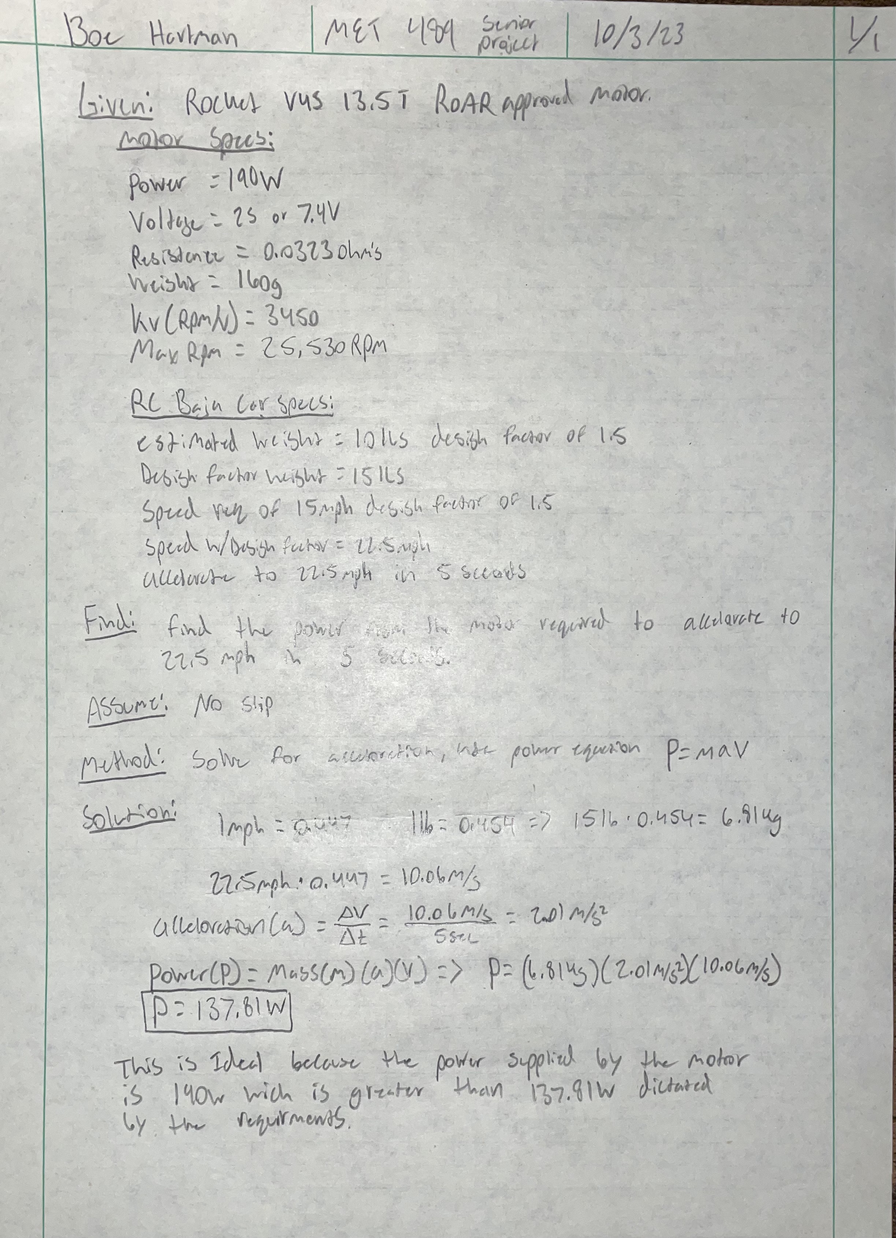
Appendix A01 – Power Required to Accelerate Vehicle

Appendix A02 – RPM, Gear Ratio, Required Torque

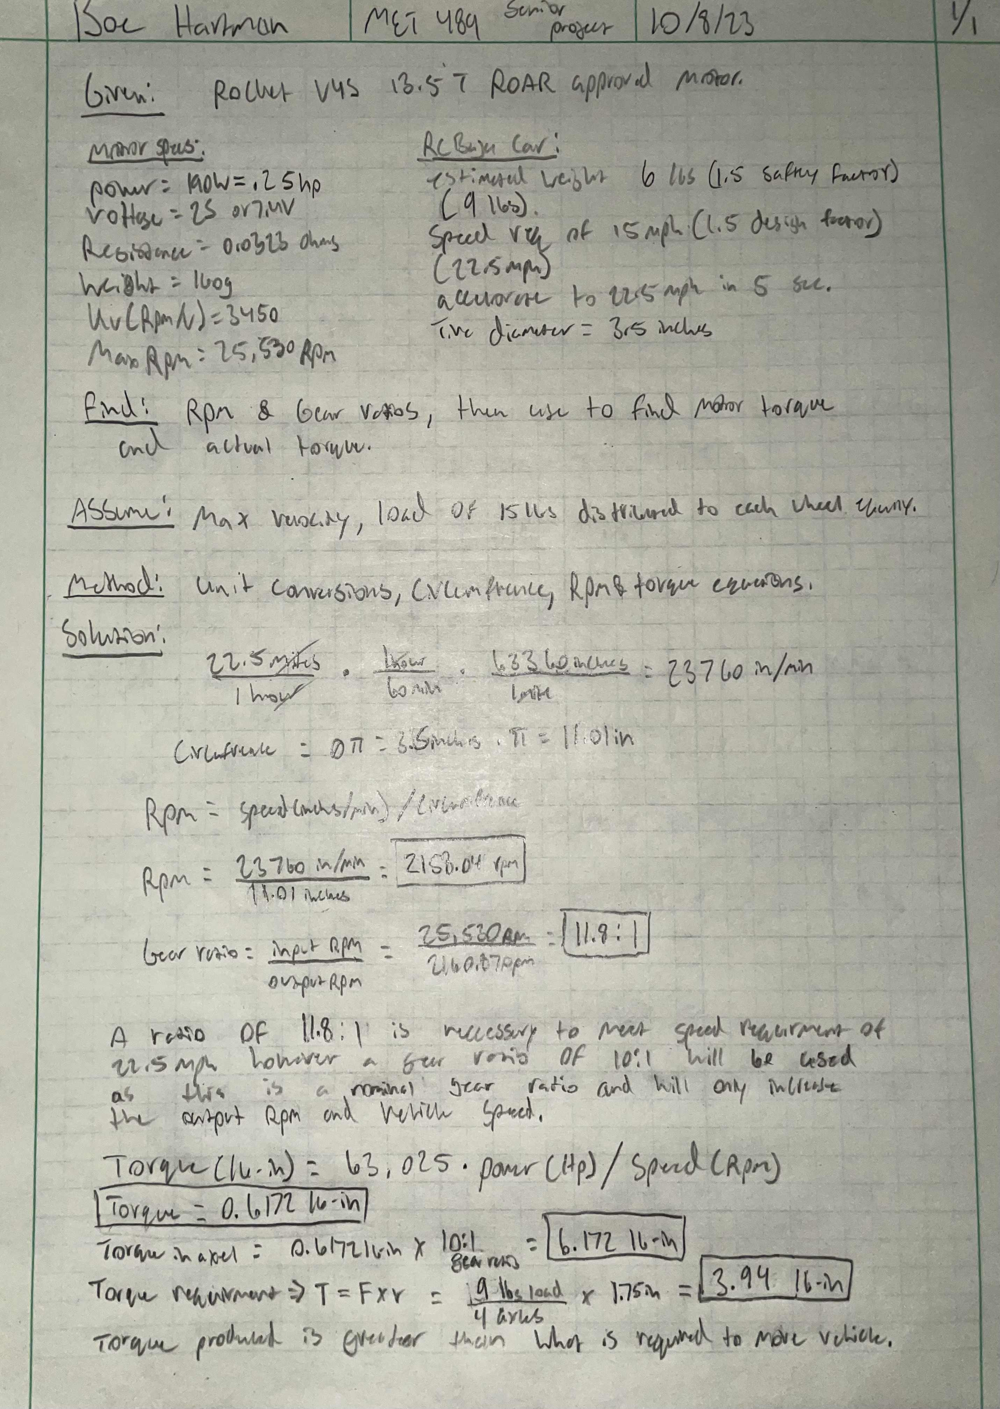

Appendix A03 – Minimum Chassis Thickness
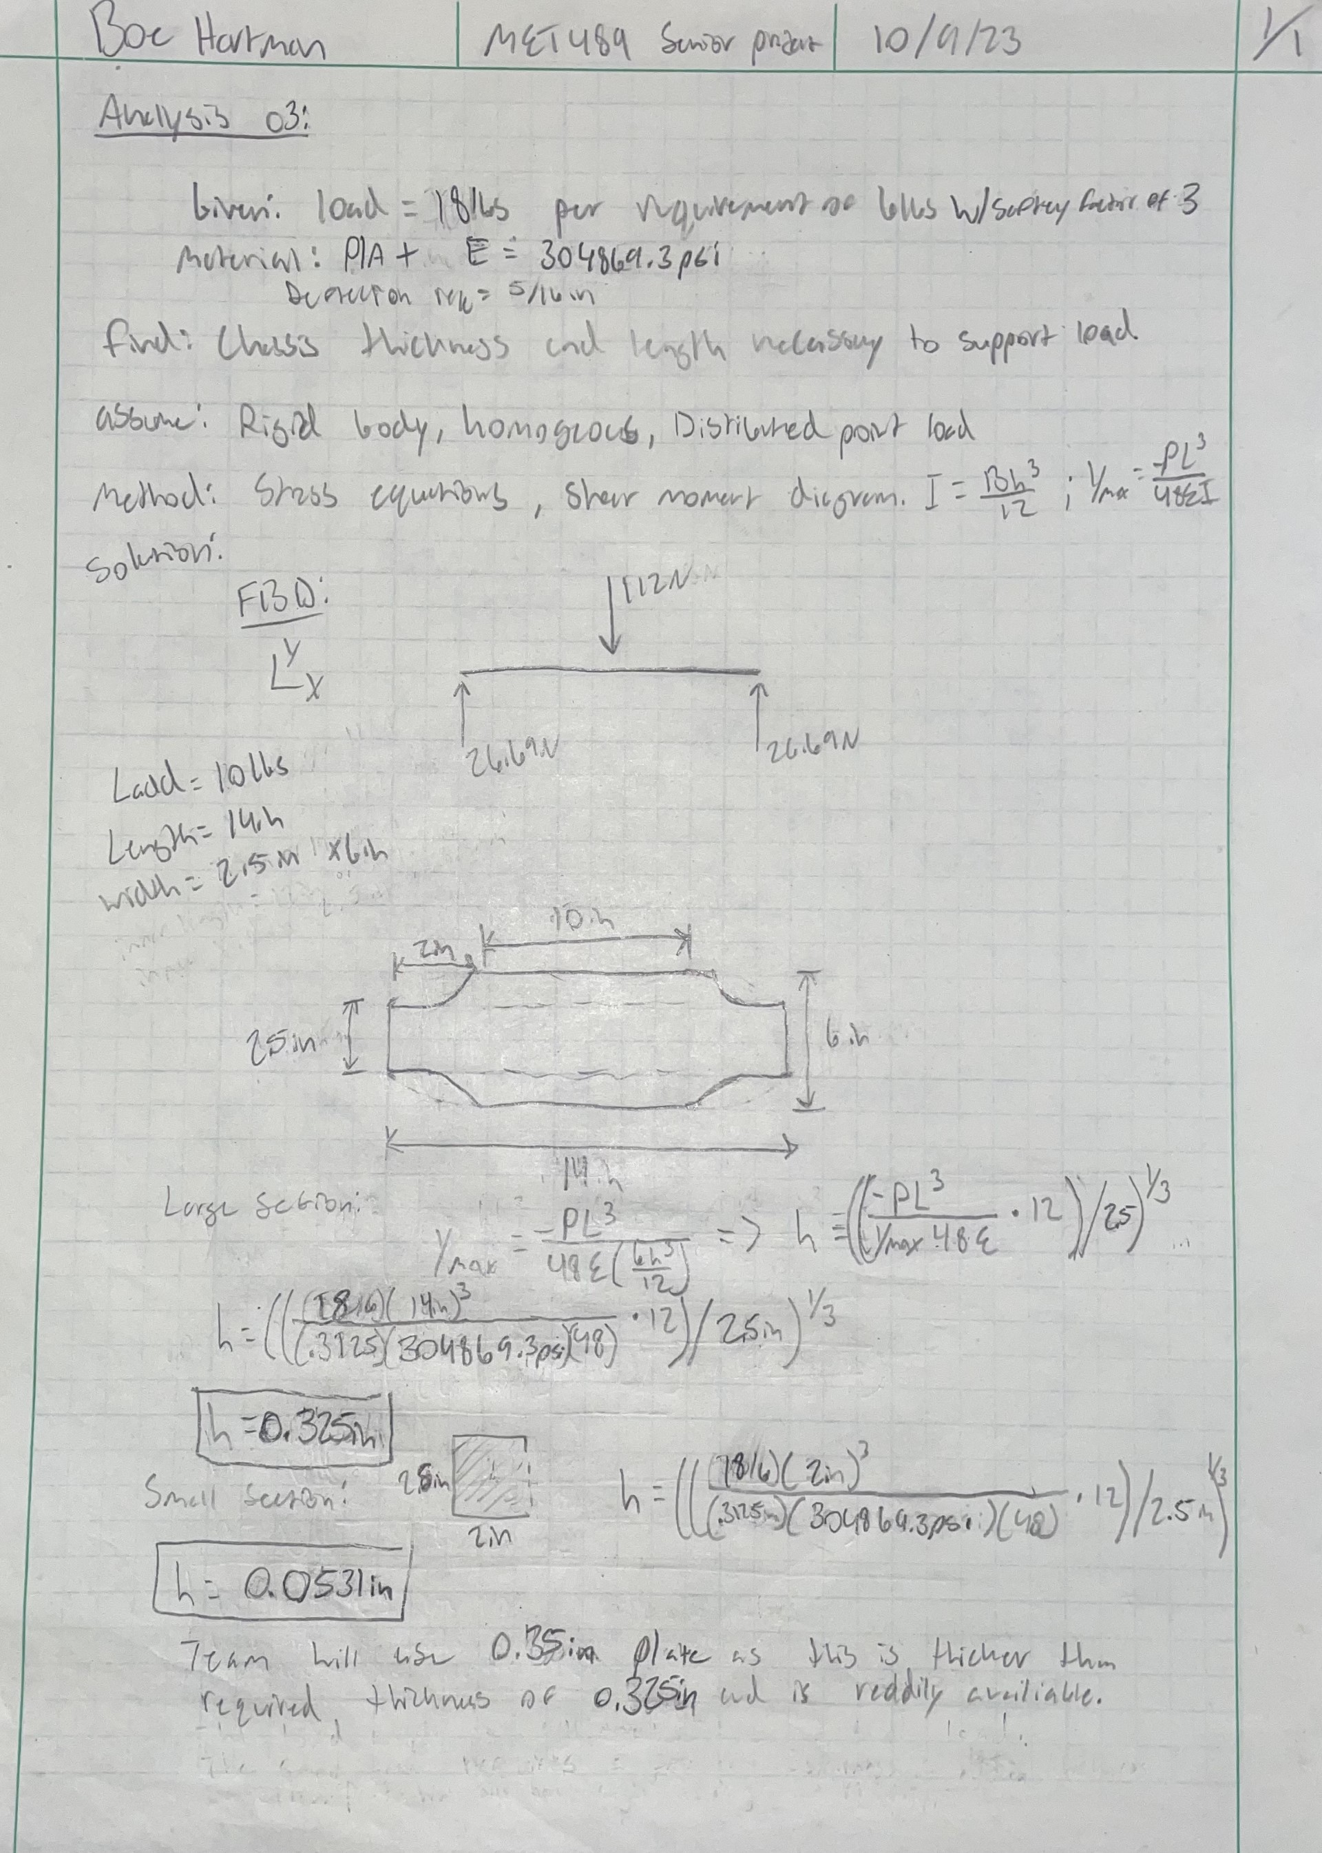

Appendix A04 – Central Driveshaft Diameter
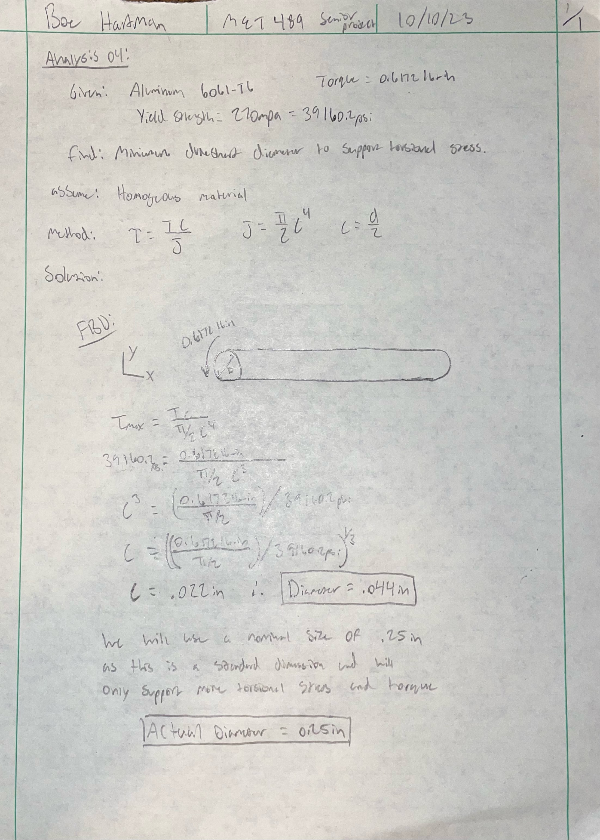

Appendix A05 – CV Axle Diameter
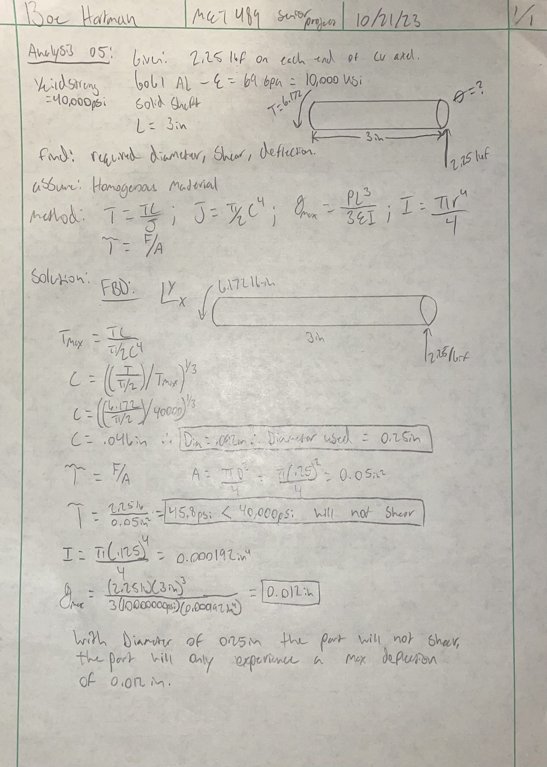

Appendix A06 – Tire Size/Diameter
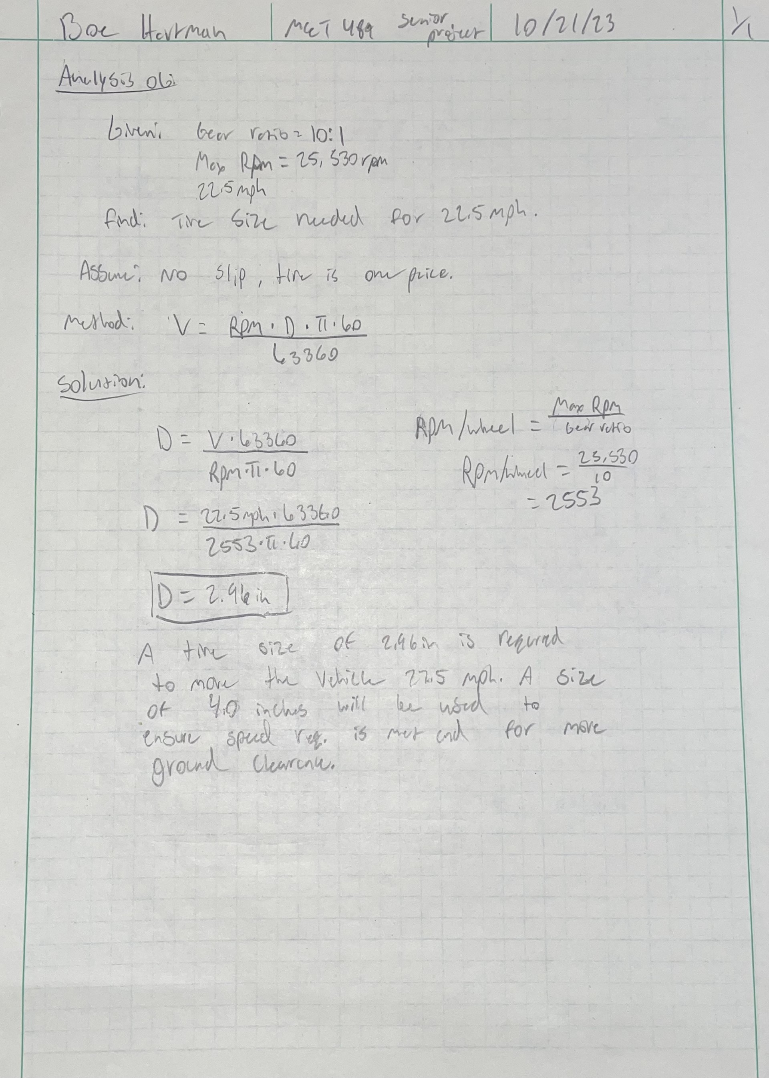

Appendix A07 - Motor Mount Thickness
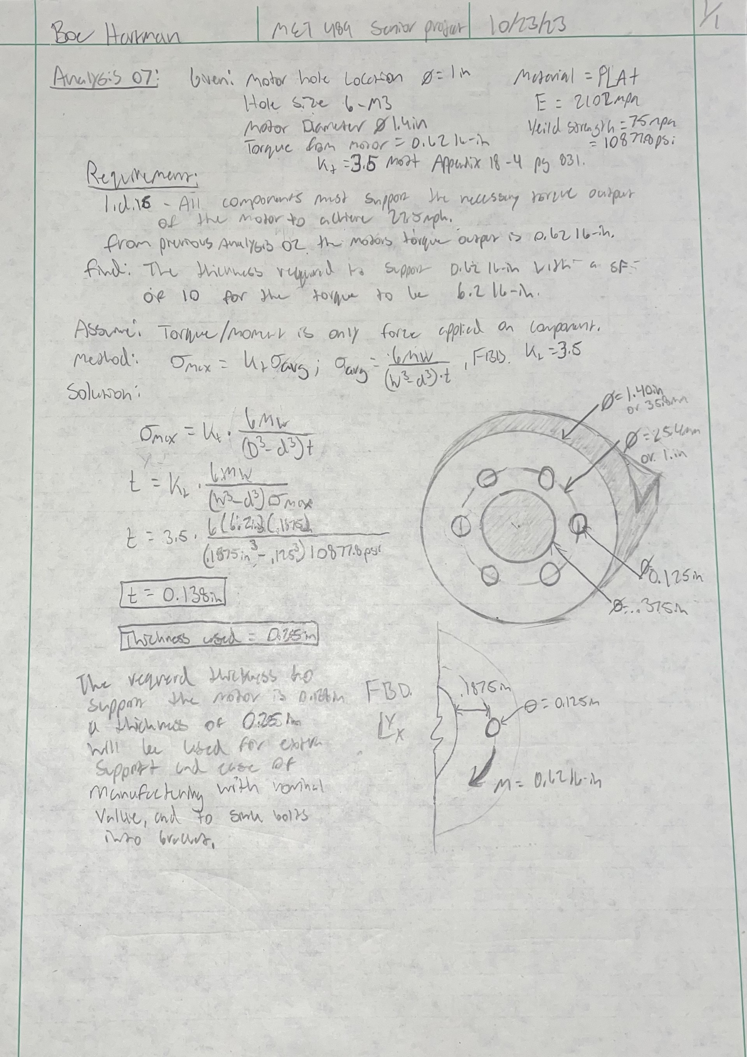

Appendix A08 – Rear Axle Diameter
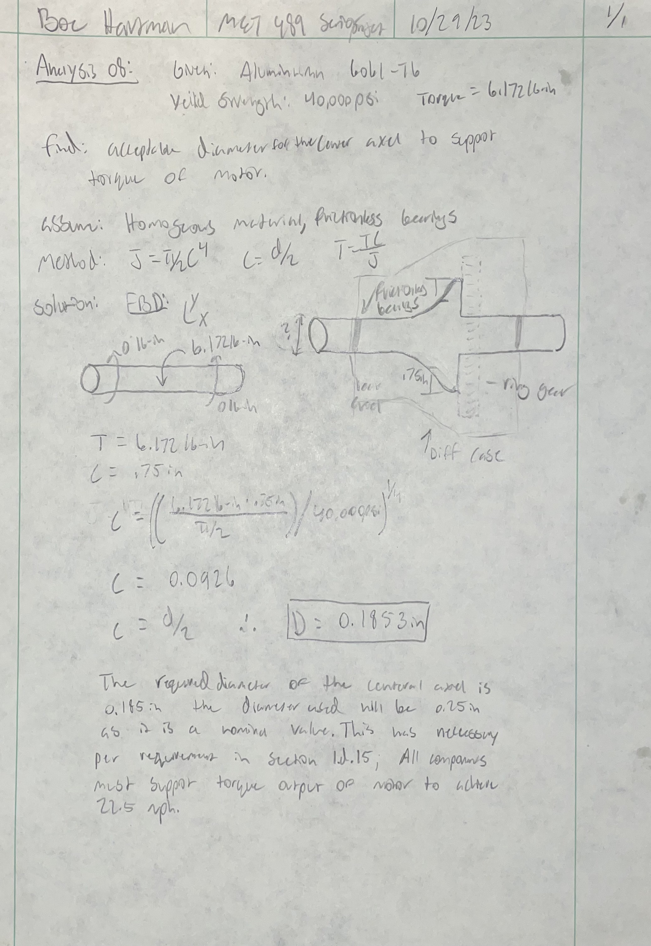

Appendix A09 – Bending & Shear Stress, 4 ft Drop
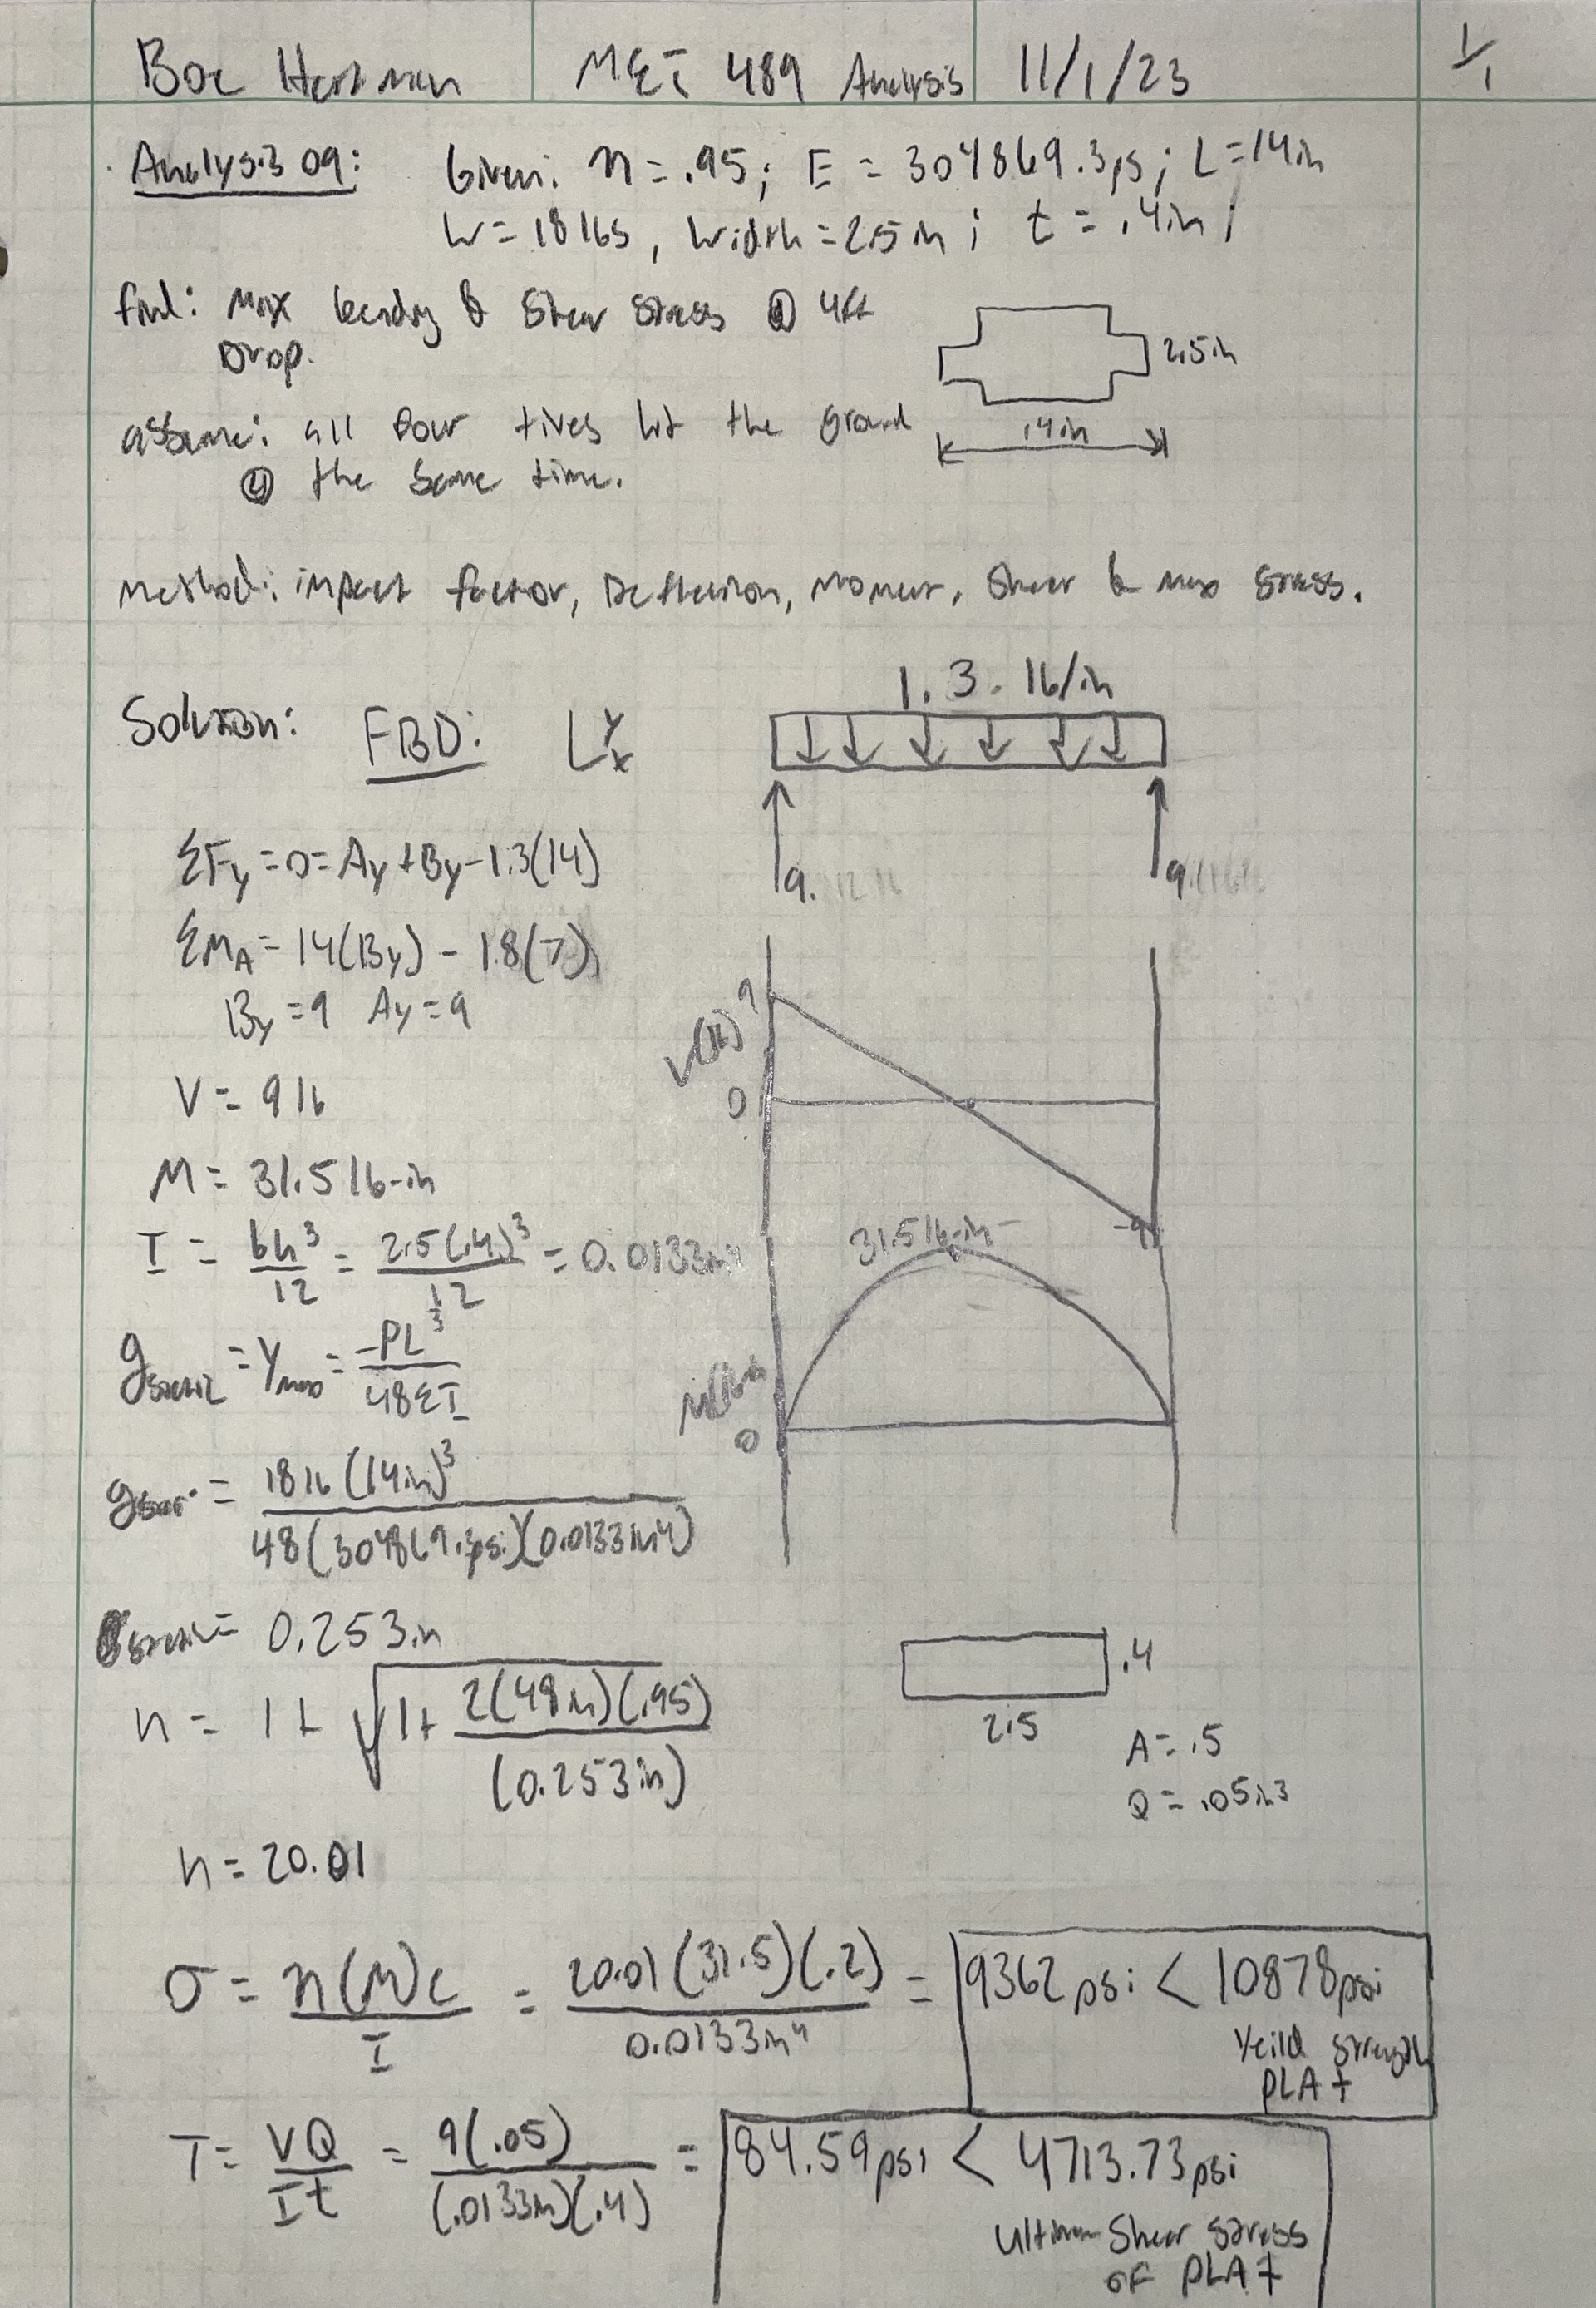

Appendix A10 – Thickness of Lower Diff Connecting Pin
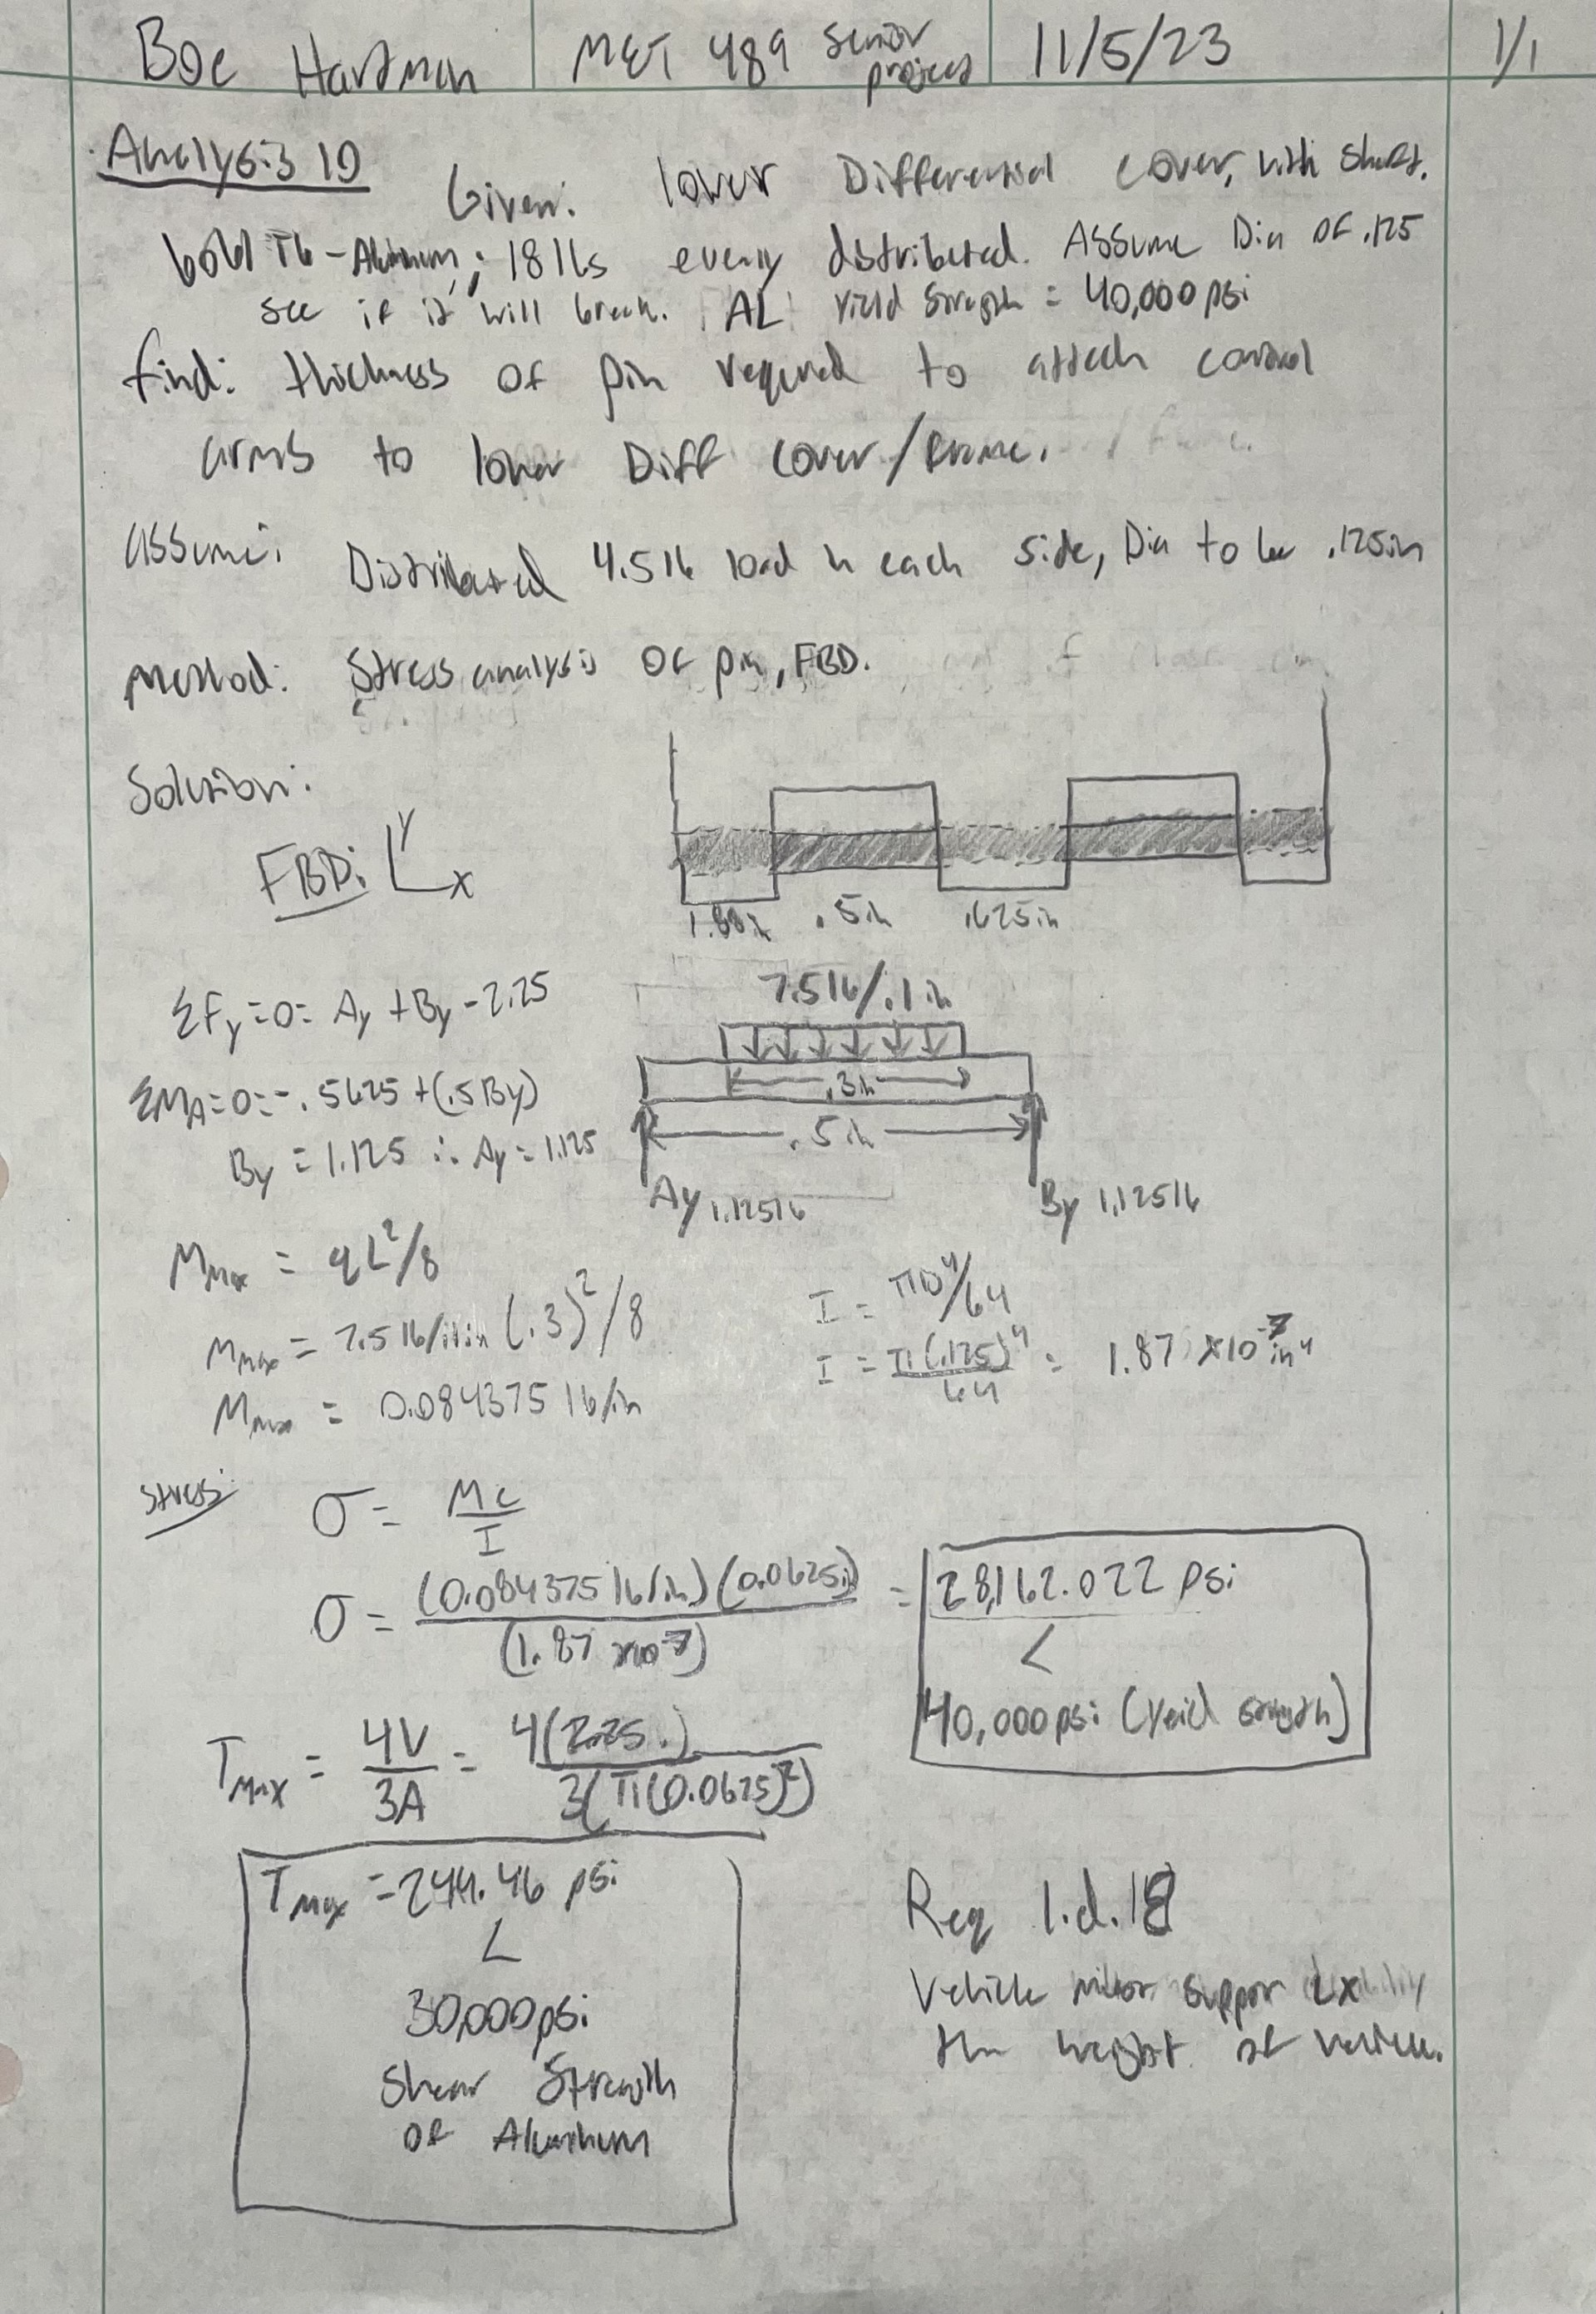

Appendix A11 – Connecting Bolt Shear Stress Analysis
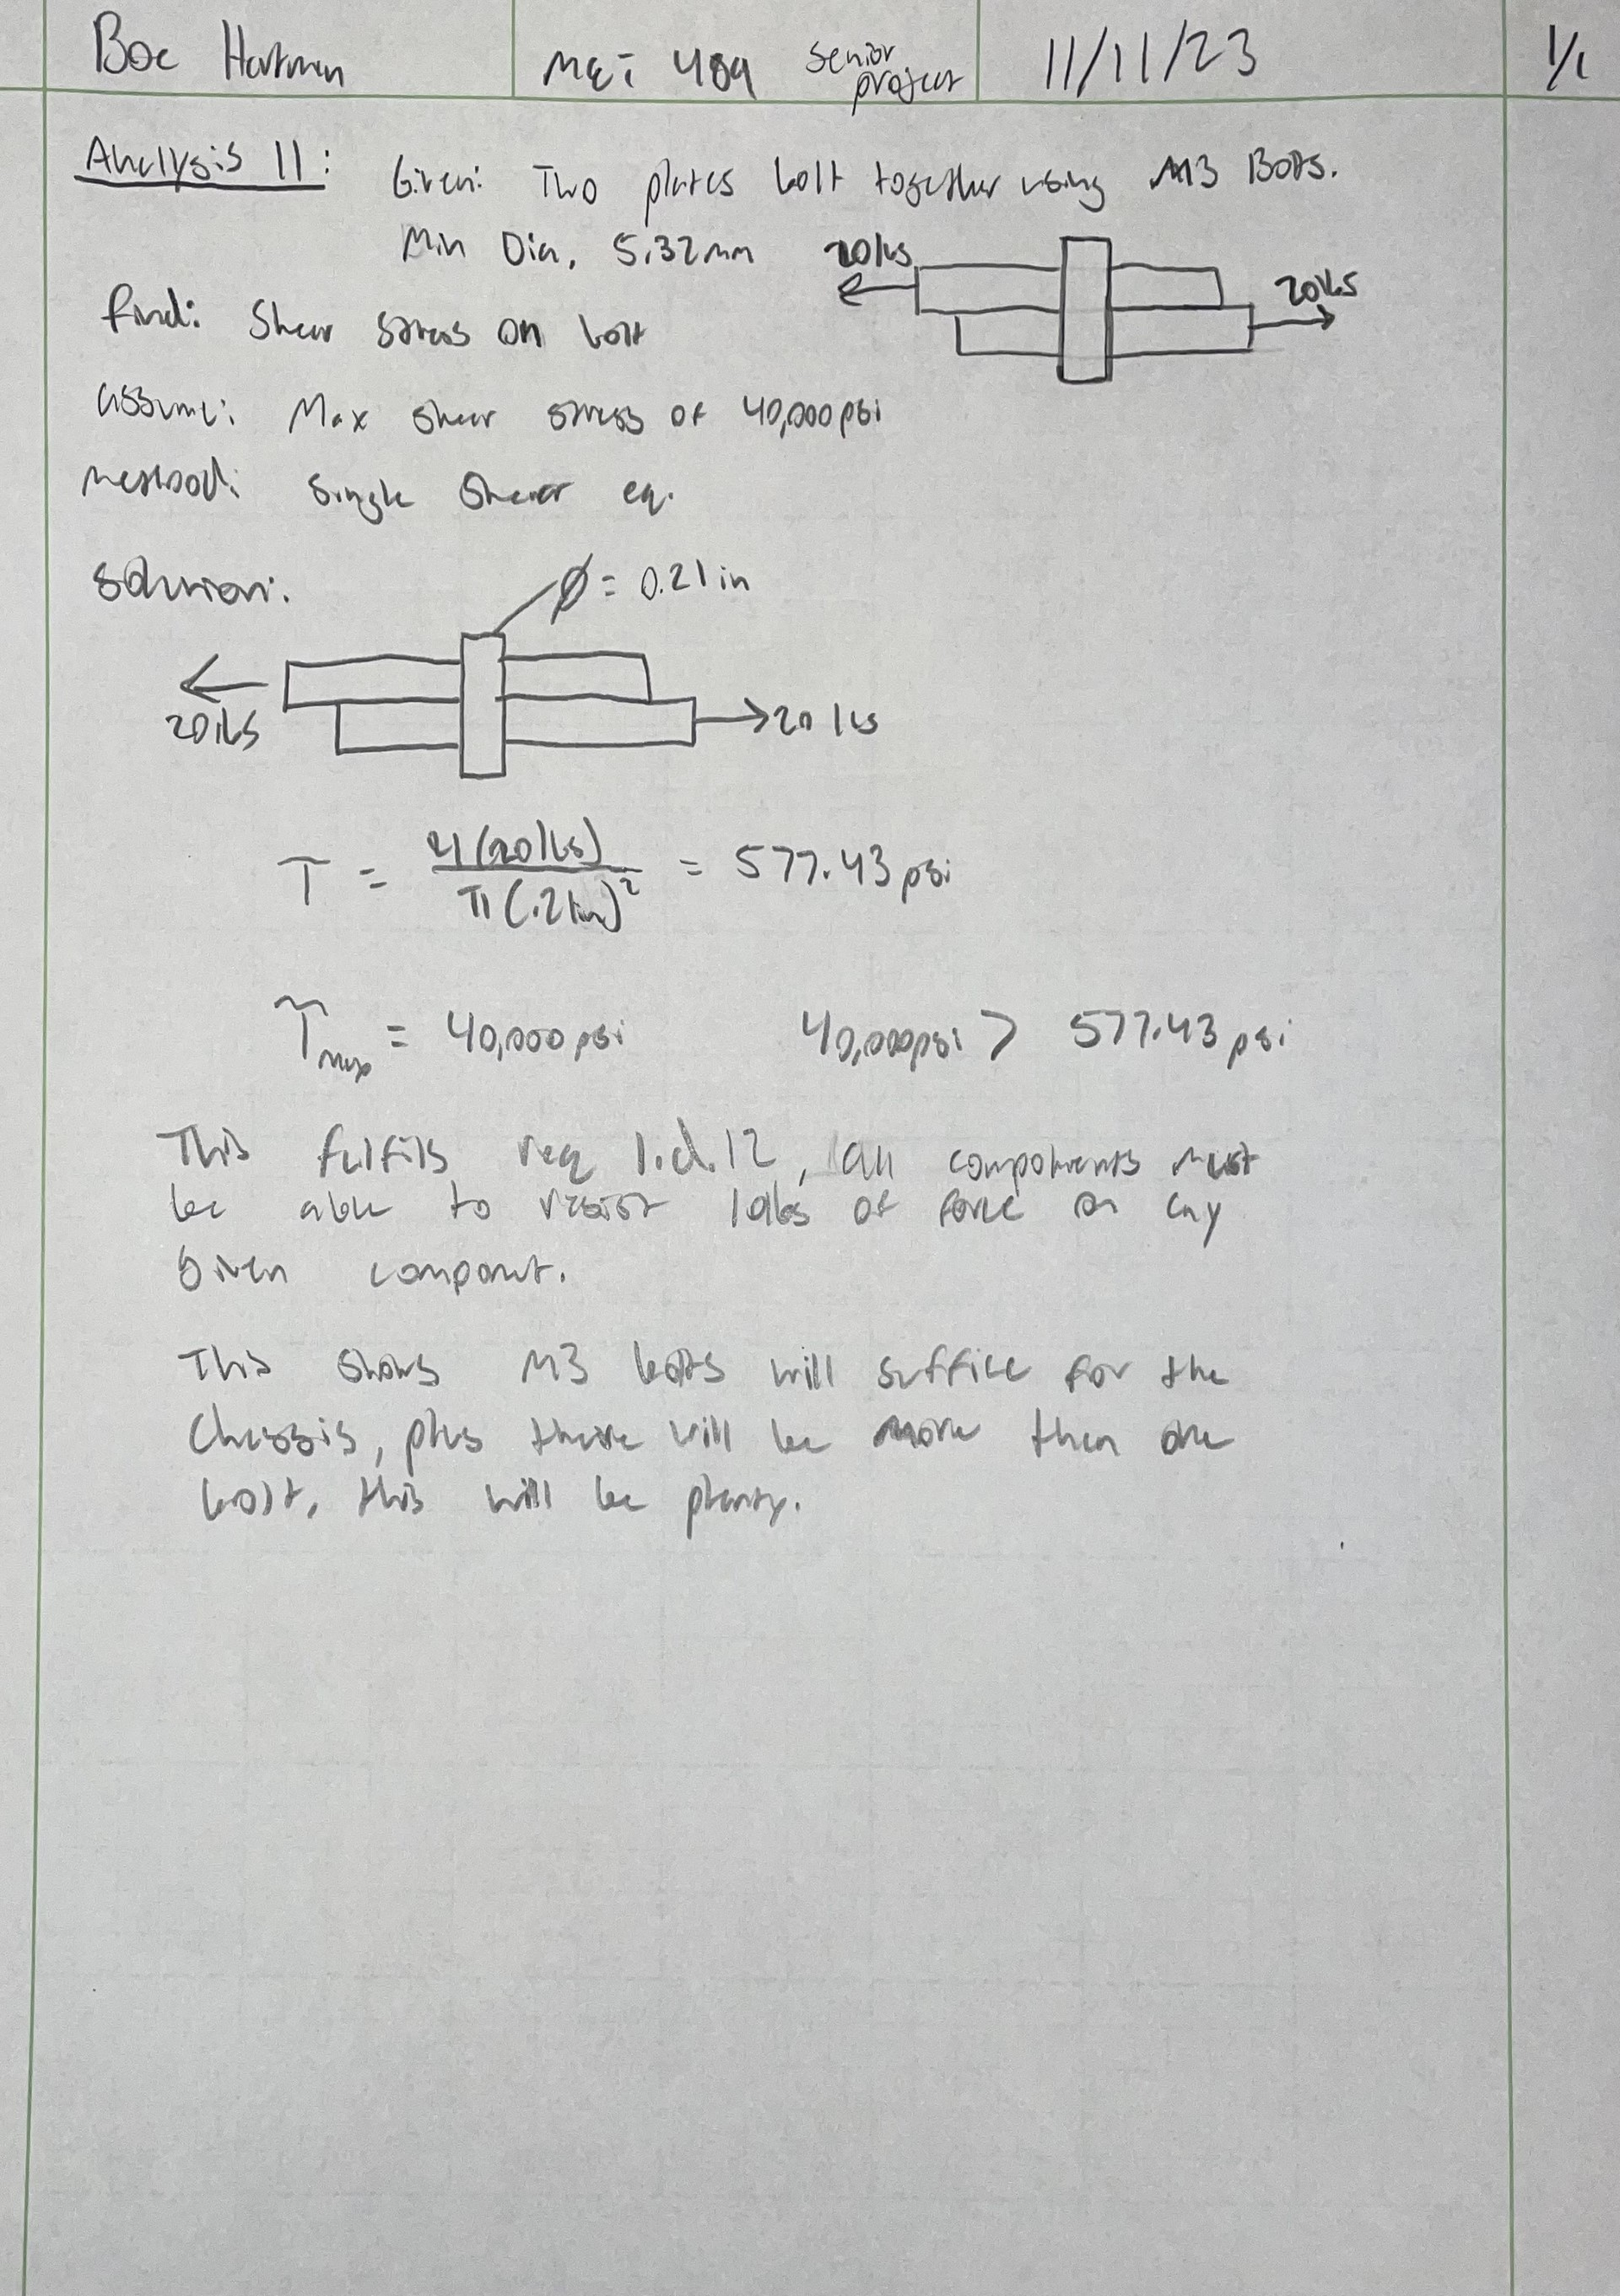

Appendix A12 – Thickness of Upper Diff Connecting Pin
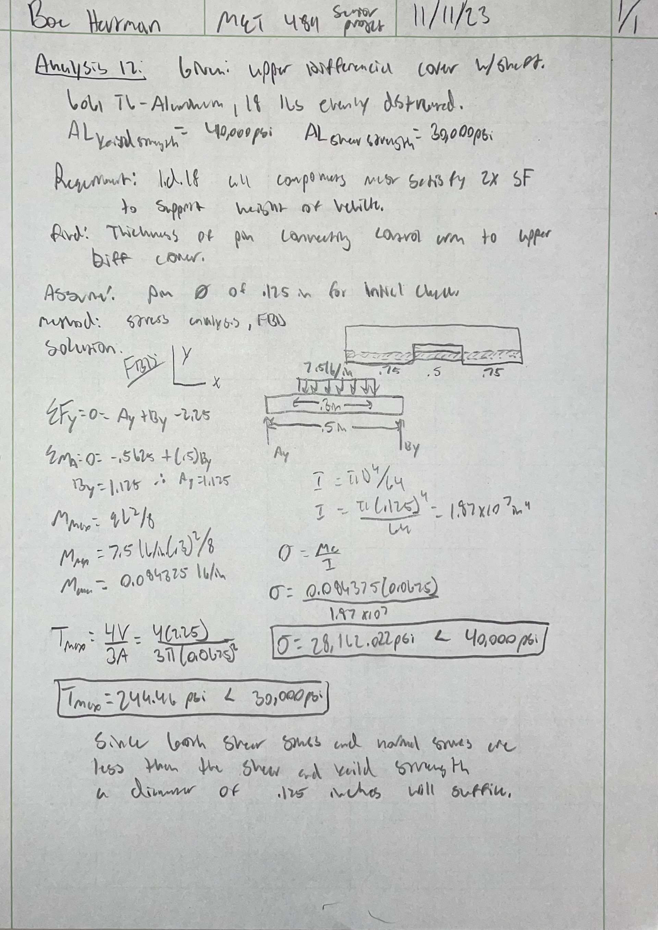

APPENDIX B - Drawings

Appendix B01 – Drawing Tree
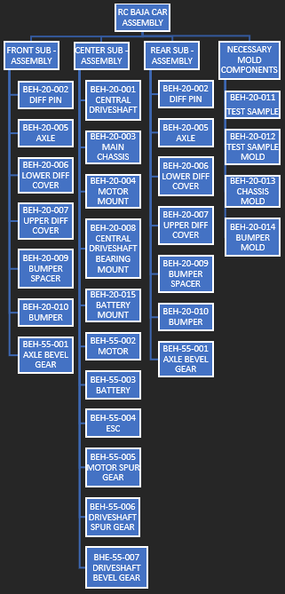

Appendix B02 – Drawing Index
Table B02. Drawing Index
Drawing Assignment Num. | Drawing #(s) | Date submitted
Upload: DWG 1 | BEH-20-001 | 10/11/23
Upload: DWG 2 | BEH-20-002 | 10/18/23
Upload: DWG 3 & 4 | BEH-20-003 and BEH-20-004 | 10/25/23
Upload: DWG 5 & 6 | BEH-20-005 and BEH-20-006 | 11/1/23
Upload: DWG 7 & 8 | BEH-20-007 and BEH-20-008 | 11/8/23
Upload: DWG 9 & 10 | BEH-20-009 and BEH-20-010 | 11/15/23
Upload: ASSY DWG | BEH-10-001 and BEH-10-002 | 11/29/23
NAN | BEH-20-011 and BEH-20-012 | 1/18/24
NAN | BEH-20-013 and BEH-20-014 | 1/26/24
NAN | BEH-20-015 | 2/02/24

Appendix B03 –BEH-10-001 – FRONT SUB-ASSEMBLY

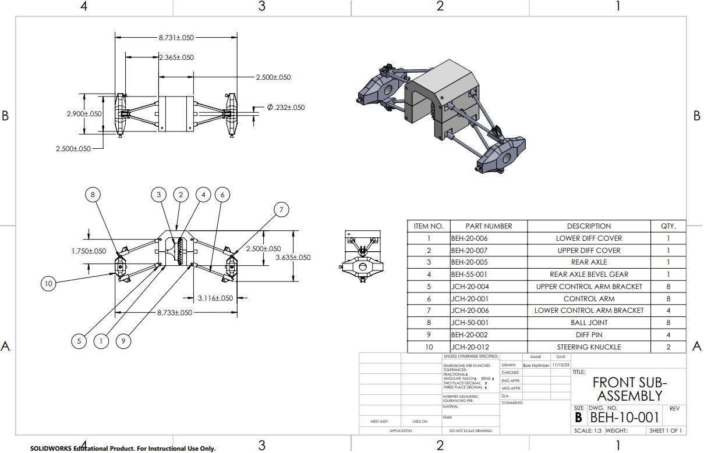

Appendix B04 – BEH-10-002 – RC BAJA CAR ASSEMBLY

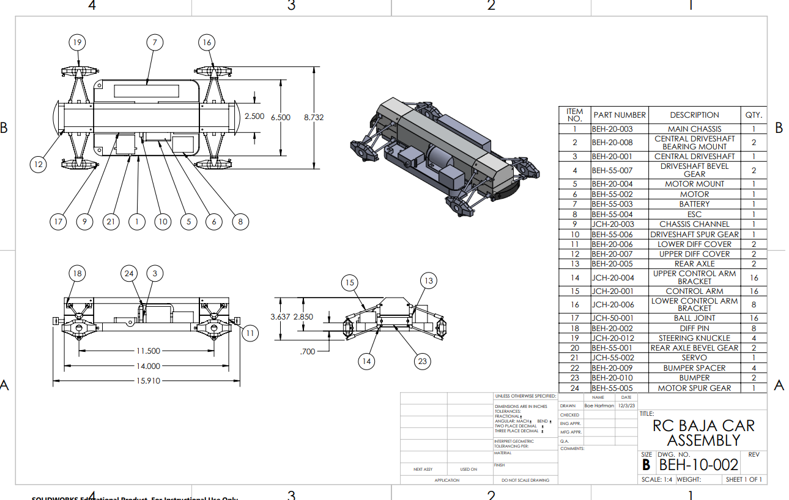

Appendix B05 – BEH-20-001 - CENTRAL DRIVESHAFT
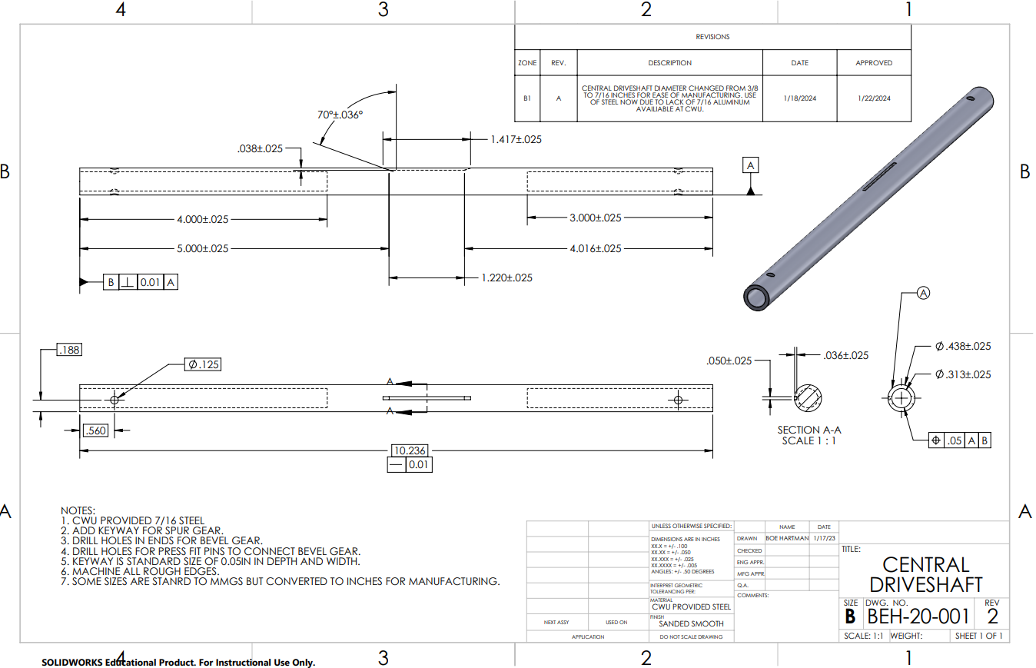

Appendix B06 – BEH-20-002 – DIFF PIN

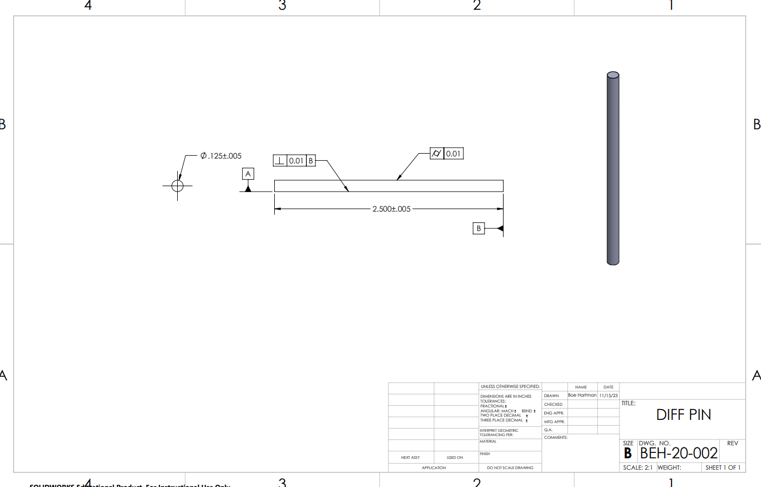

Appendix B07 – BEH-20-003 – MAIN CHASSIS
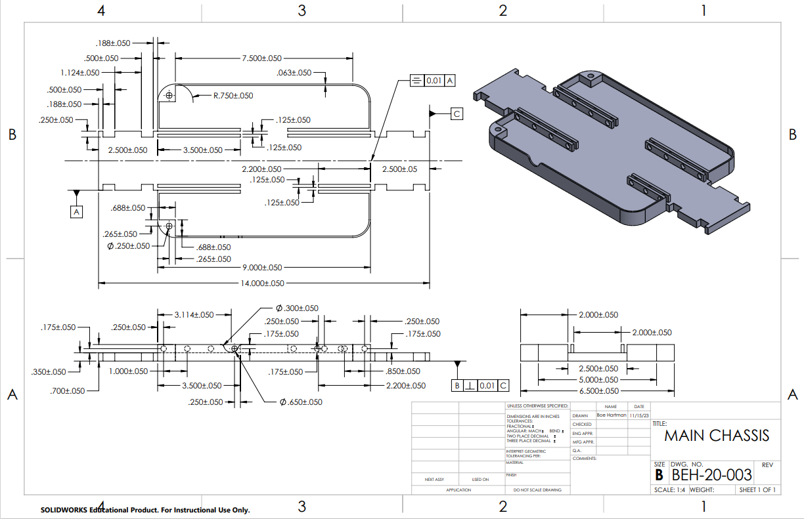

Appendix B08 – BEH-20-004 – MOTOR MOUNT

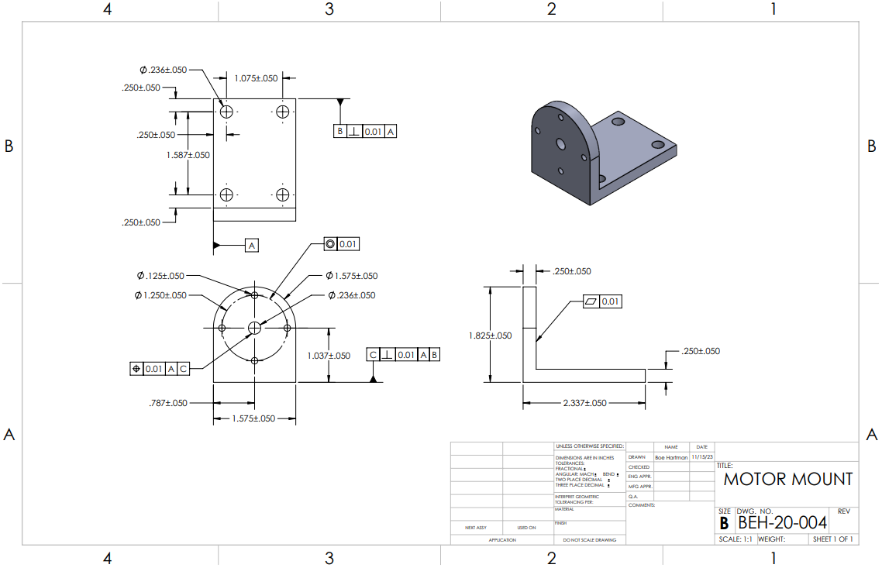

Appendix B09 – BEH-20-005 - REAR AXLE

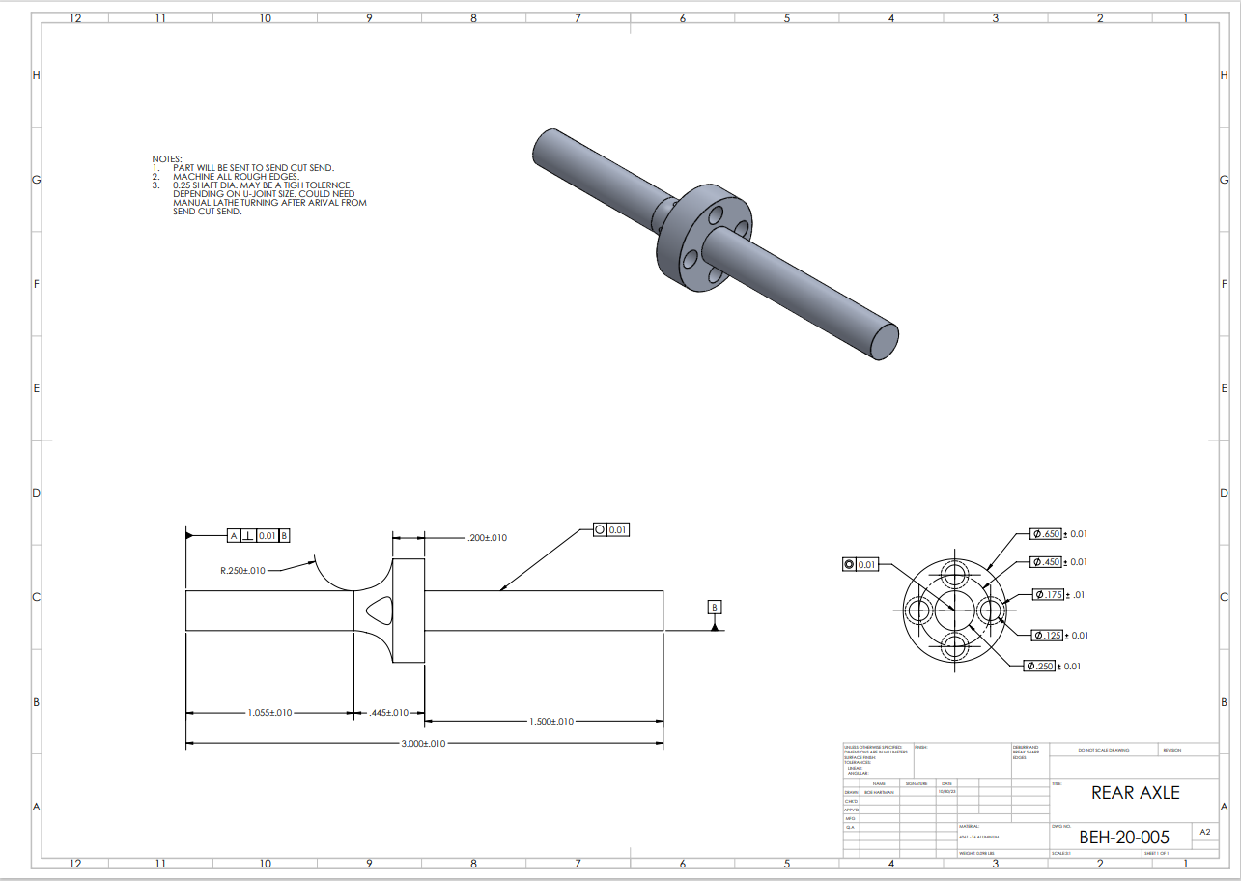

Appendix B10 – BEH-20-006 – LOWER DIFF COVER

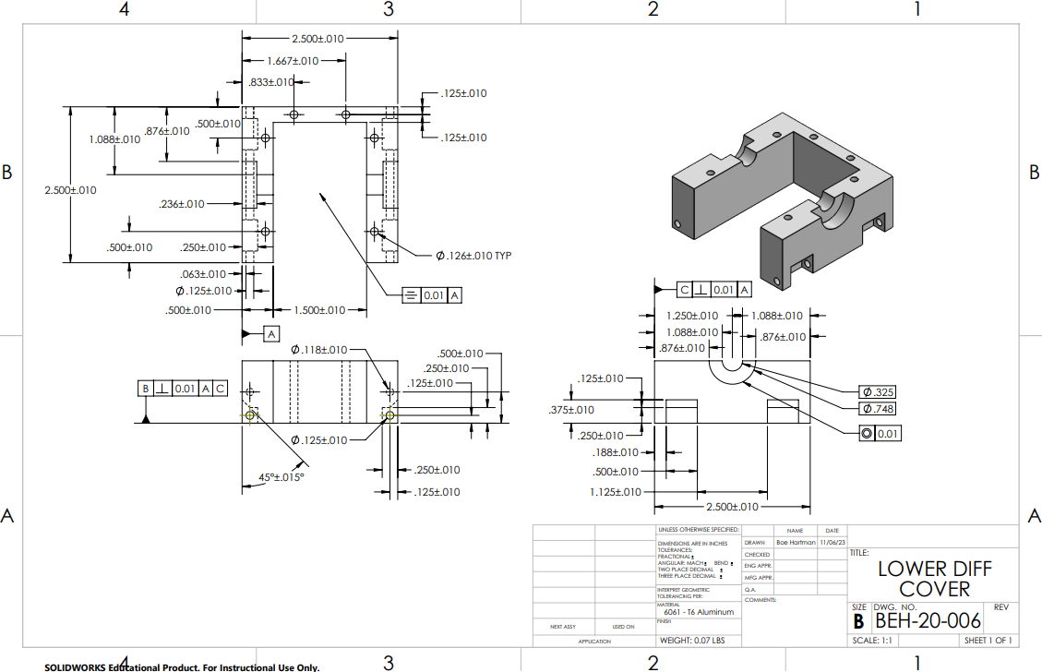

Appendix B11 – BEH-20-007 – UPPER DIFF COVER

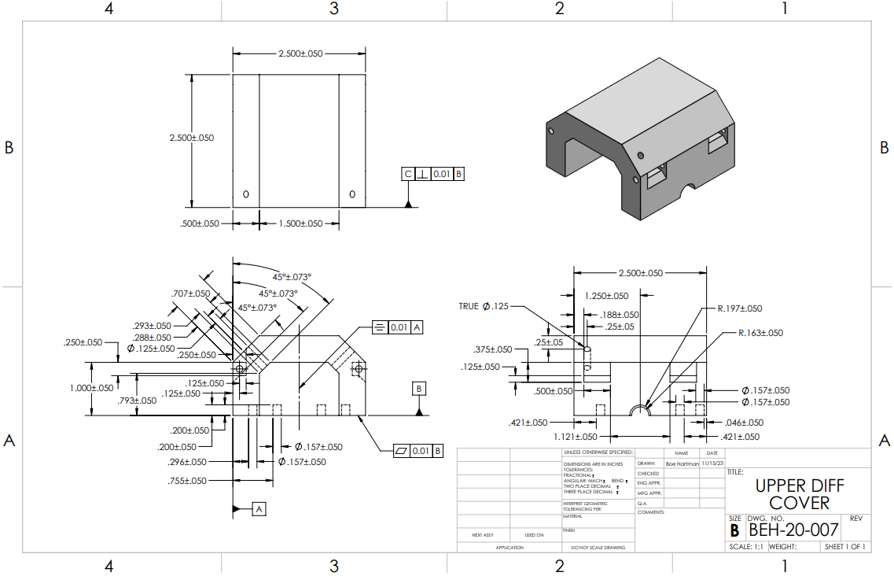

Appendix B12 – BEH-20-008 – CENTRAL DRIVESHAFT BEARING MOUNT
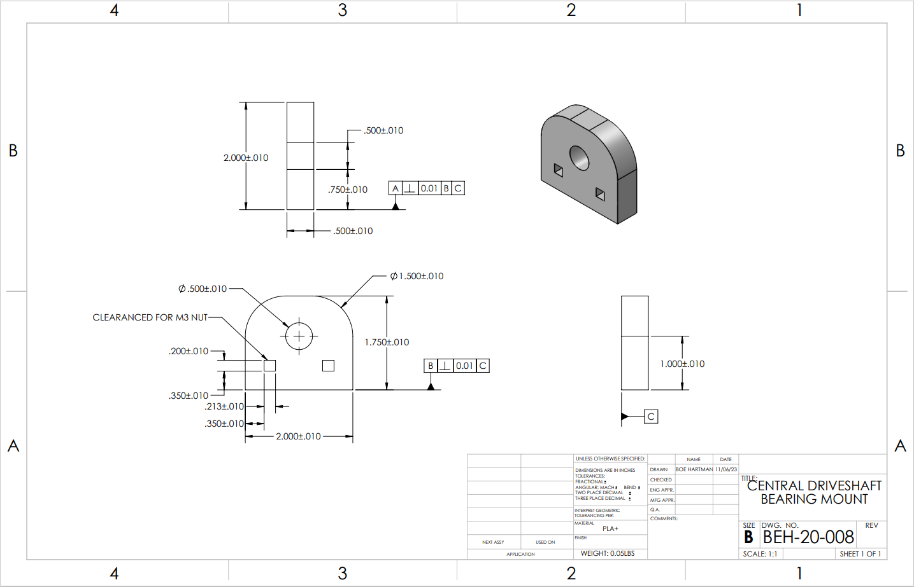

Appendix B13 – BEH-20-009 – BUMPER SPACER

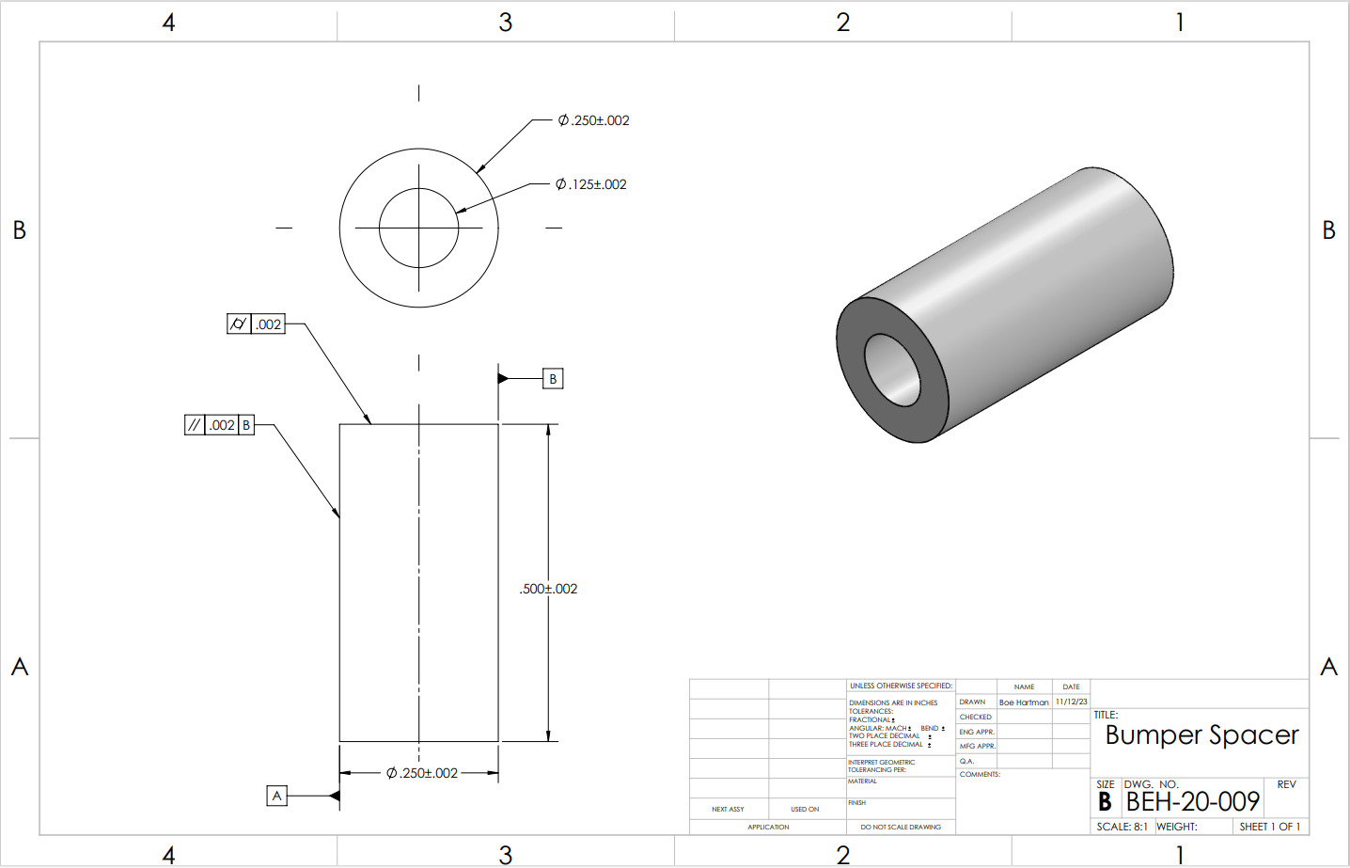

Appendix B14 – BEH-20-010 – BUMPER

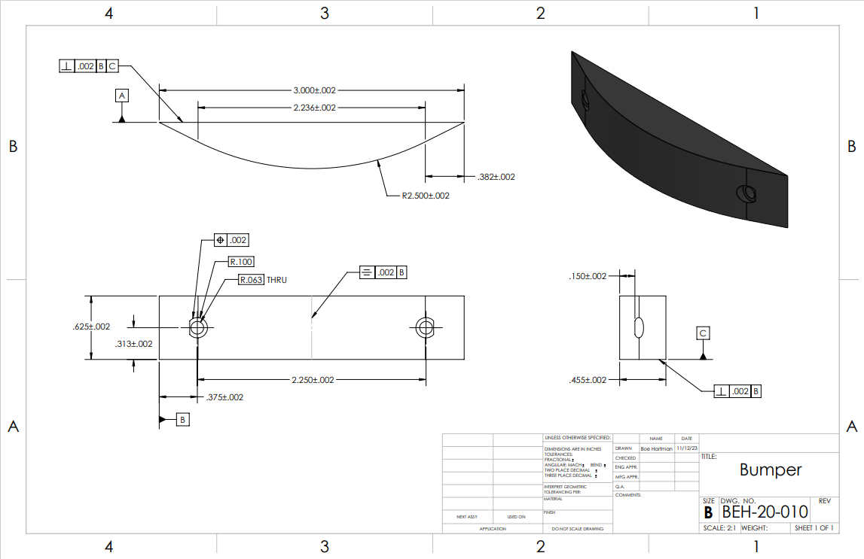

Appendix B15 – BEH-20-011 – TEST SAMPLE

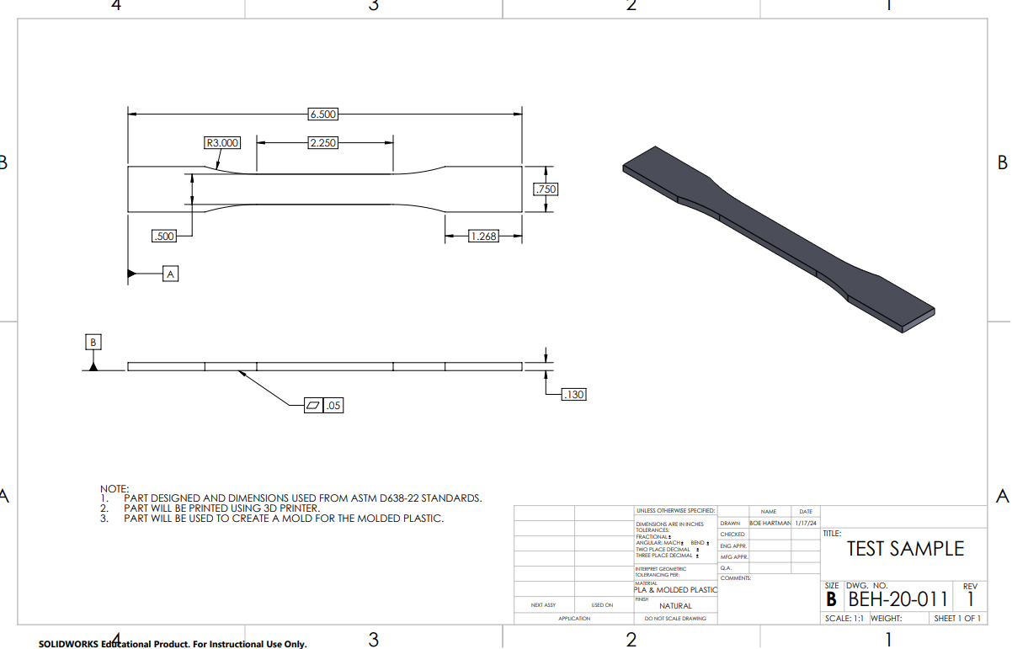

Appendix B16 – BEH-20-012 – TEST SAMPLE MOLD
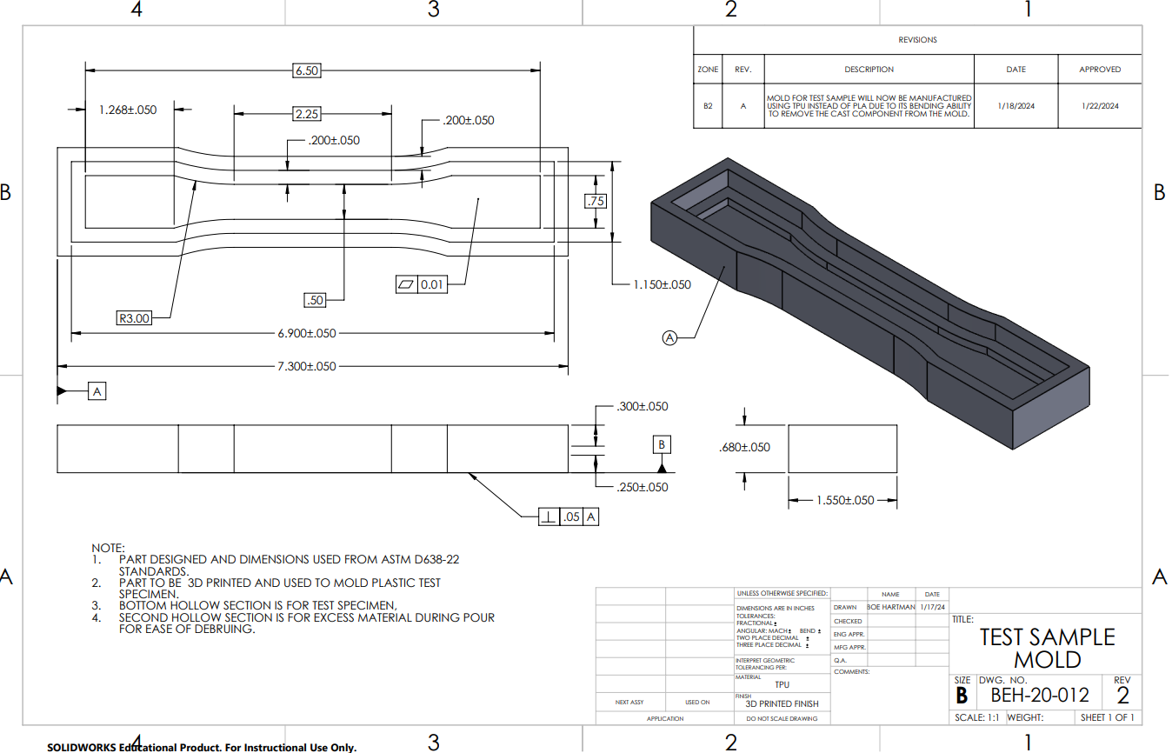

Appendix B17 – BEH-20-013 – CHASSIS MOLD
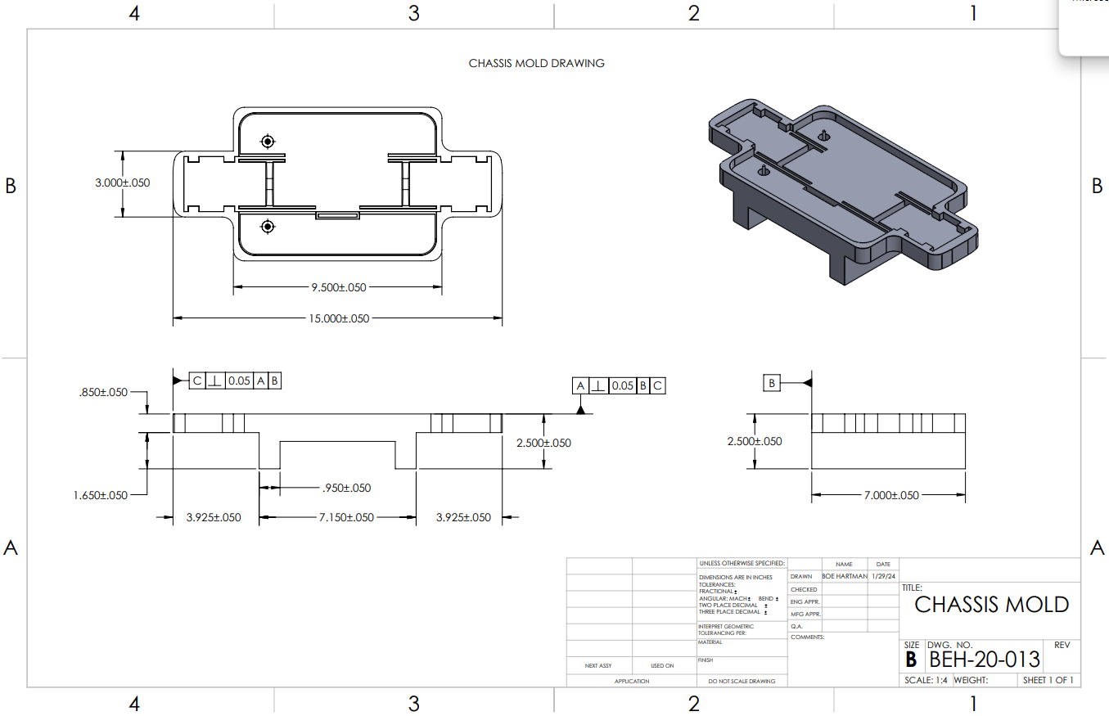

Appendix B18 – BEH-20-014 – BUMPER MOLD
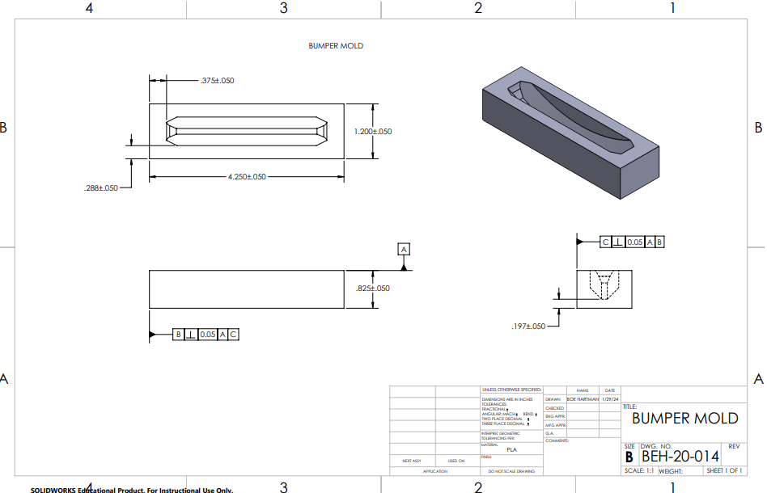

Appendix B19 – BEH-20-015 – BATTERY MOUNT
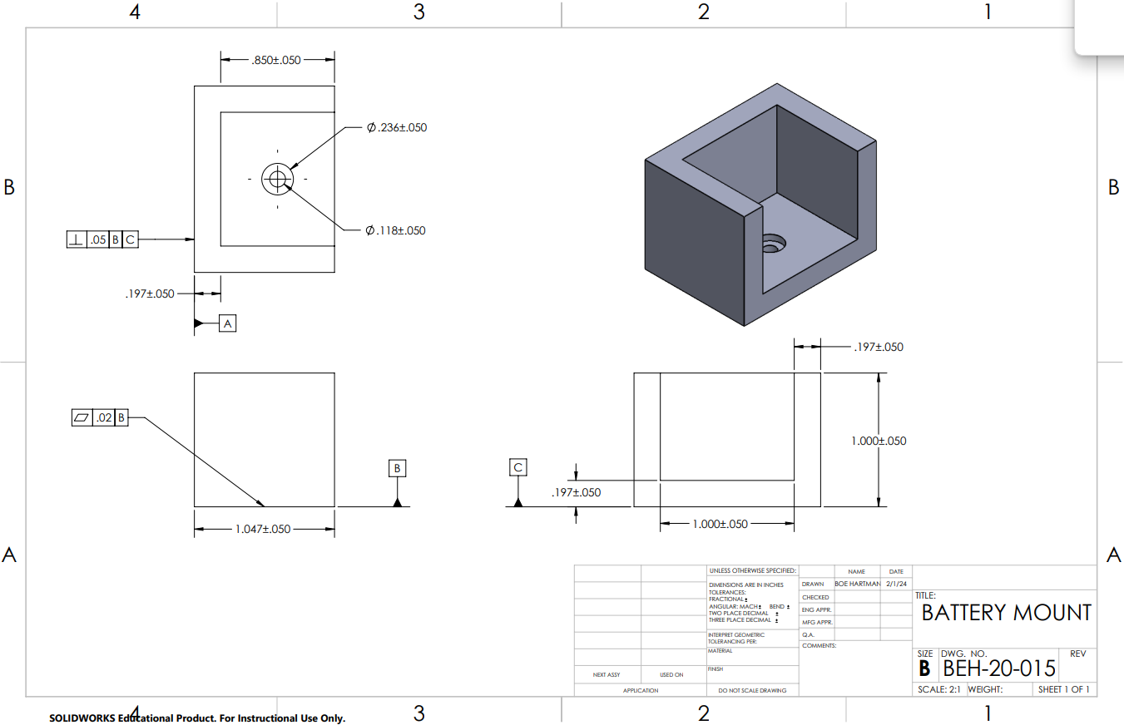

APPENDIX C – Parts List and Costs
Table C1. Parts List
Part Number | Qty | Part Description | Source | Cost | Disposition
BEH-20-001 | 1 | Central Driveshaft  ¼’’dia x 12’’ long | CWU | $25 | Donated
BEH-20-002 | 8 | Upper Diff Pin | CWU | ~$2 | Donated
BEH-20-003 | 1 | Main Chassis | CWU | $8 | Donated
BEH-20-004 | 1 | Motor Mount | CWU | $2 | Donated
BEH-20-005 | 2 | Axle | CWU | $25 | Donated
BEH-20-006 | 2 | Lower Diff Cover | CWU | $5 | Donated
BEH-20-007 | 2 | Upper Diff Cover | CWU | $5 | Donated
BEH-20-008 | 2 | Central Driveshaft Bearing Mount | CWU | $5 | Donated
BEH-20-009 | 2 | Bumper Spacer | CWU | $2 | Donated
BEH-20-010 | 2 | Bumper | CWU | $5 | Donated
BEH-20-011 | 1 | Test Sample | CWU | $5 | Donated
BEH-20-012 | 1 | Test Sample Mold | CWU | $5 | Donated
BEH-20-013 | 1 | Chassis Mold | CWU | $10 | Donated
BEH-20-014 | 1 | Bumper Mold | CWU | $5 | Donated
BEH-20-015 | 2 | Battery Mount | CWU | $5 | Donated
BEH-50-001 | 30 | M3x0.5mm Socket Head Screws | McMaster Carr  Mfg Part#: 91290A572 | $25 | Donated
BEH-55-001 | 2 | Axle Bevel Gear | Amazon | $7 | Donated
BEH-55-002 | 1 | Motor | Hobby King  SKU: 9192000195-0 | $138 | Purchased
BEH-55-003 | 1 | Battery | Hobby King  SKU: 9067000527-0 | $36 | Purchased
BEH-55-004 | 1 | ESC | Hobby King  SKU: 9192000195-0 | $69 | Purchased
BEH-55-005 | 1 | Motor Spur Gear | Amazon | $10 | Donated
BEH-55-006 | 1 | Driveshaft Spur Gear | Amazon | $10 | Donated
BEH-55-007 | 2 | Driveshaft Bevel Gear | Amazon | $7 | Donated
BEH-55-008 | 4 | CV Axle | Amazon | $42 | Donated
 |  |  | Cost Total: | $468

APPENDIX D – Budget

Table D1. Project Budget.
Item | Qty | Description | Cost
Labor | 1 | Time Spent Manufacturing Parts | $4000
Material | 2 | Material Used to Manufacture Parts | $50
Purchased Parts | 12 | Parts That Will be Purchased | $243
Manufacturing | 1 | Parts sent to Send-Cut-Send | $0
Contingency | 1 | Money allocated for unforeseen circumstances | $100
Donations | 3 | Parts Donated | $215
 |  | Total Cost: | $4608

APPENDIX E - Schedule

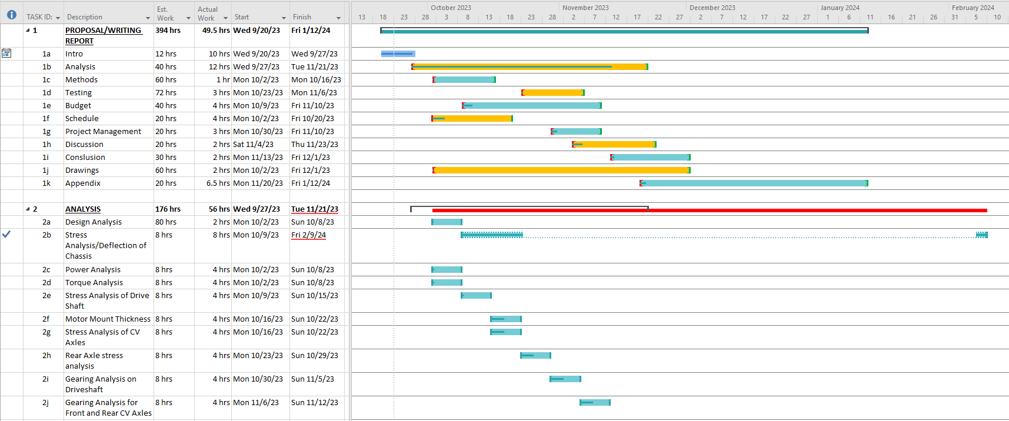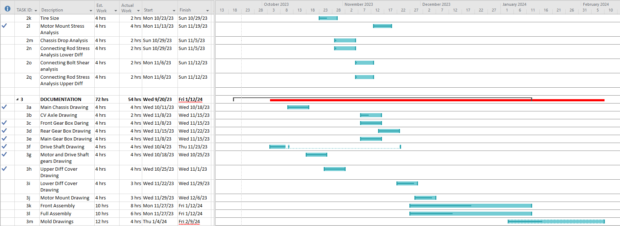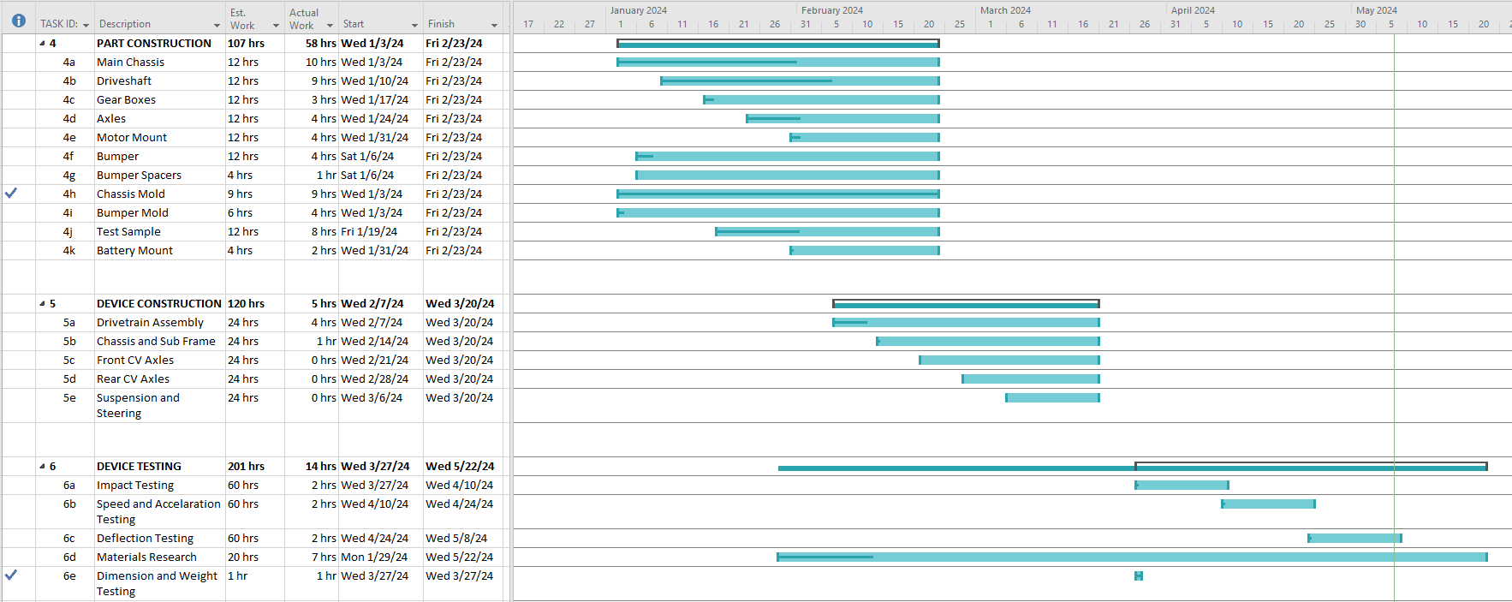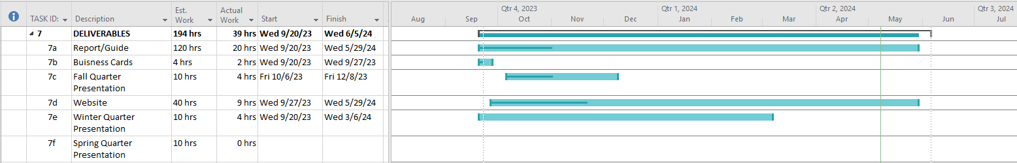
Figure E.01 – Gantt Chart

Appendix F – Expertise and Resources

Appendix F01 Decision Matrix for Drive Type

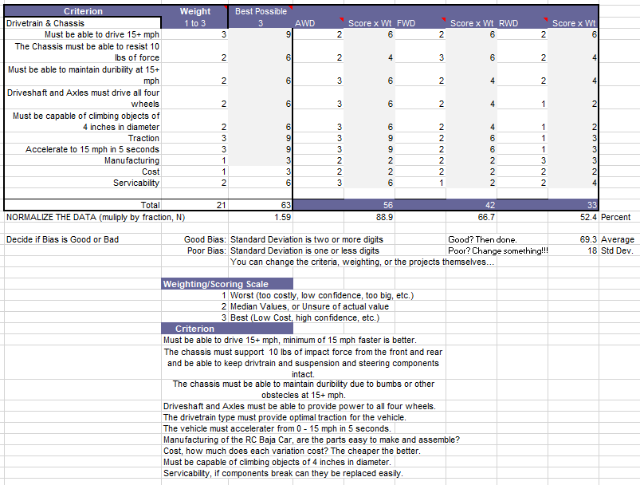

Appendix F02 Decision Matrix for Material Selection
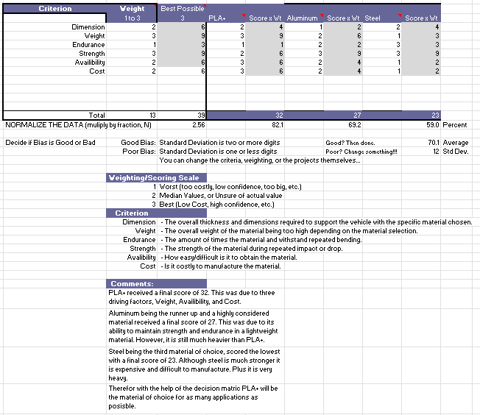

Appendix F03 Decision Matrix for Chassis Components Manufacturing process
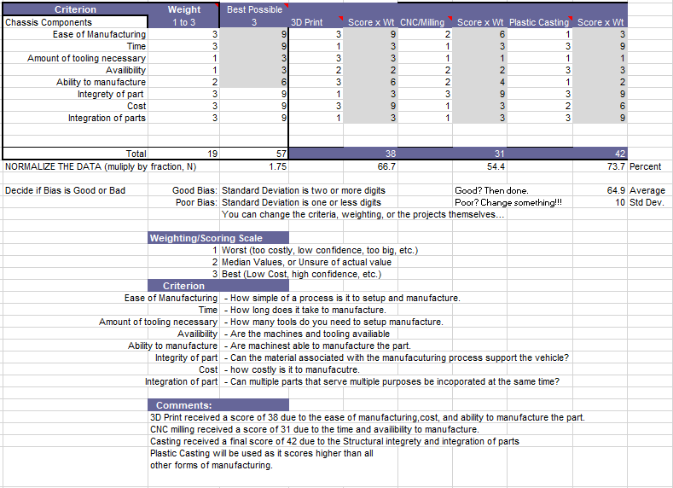

Appendix F04 Decision Matrix for Drivetrain Components Manufacturing process
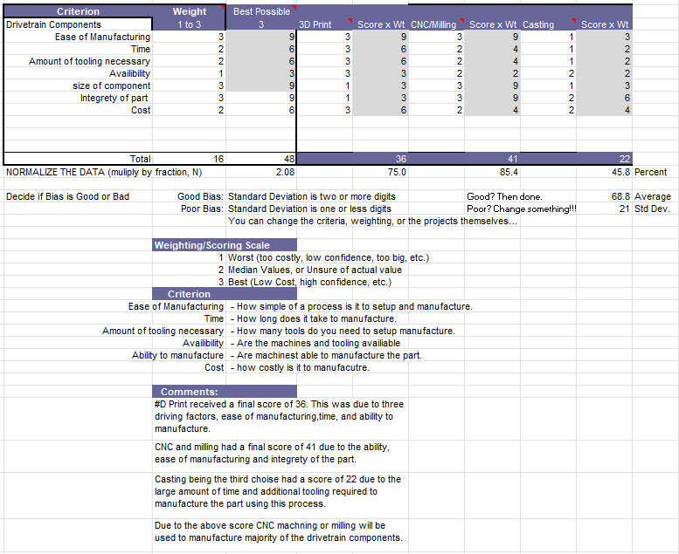

APPENDIX G – Testing Report

Appendix G1 - Acceleration Test

Introduction

Method/Approach

Test Procedure:

Summary/Overview:
This procedure documents the process of recording the acceleration test for the RC Baja Car. The RC Baja Car is built by students within the CWU MET program for the ASME RC Baja Car competition. The vehicles are built and designed around the competition guidelines, specifically the ROAR approved motor and battery as these have a direct impact on the acceleration testing. The following information describes the test information and procedure to replicate the test.

Time:
The test was conducted on 3/8/24 from 8:00am – 10:00am in Houge in front of the machine shop on the shop floor. Though the test can be complete in any area in which has 30ft of runway available. A total of 40 minutes is necessary for setup and clean up. During setup 20 minutes are served as time to setup the runway along with gather all measuring devices. During cleanup 20 minutes are served as time to dissemble the runway and put away all measuring devices. The remainder of the 80 minutes are used for testing and recording data.

Place:
Outside Houge Hall (In front of machine shop, loading dock), Central Washington University campus in Ellensburg, WA.

Required Equipment:
- One cell phone to record
- Laptop with excel or google sheets
- RC Baja Car
- Rope tape measure (30ft minimum)
- Stopwatch (Can use that of cell phone)
- Painter’s tape
- Calculator
Risk/Safety:
Risk associated with the test can be mitigated by ensuring all measurements are accurate, the battery of the vehicle is fully charged, and all measuring and recording devices have an adequate charge to last the entirety of the test.
Safety associated with the test is prevalent as the vehicle is reaching speeds greater than 15mph which could lead to possible injury if anyone is to walk into the runway. The runway must be clear of obstruction (including people). Safety glasses are required to be wore while testing is in place.
Test Procedure:
- Collect all required equipment.
  - Cell phone to record video of each run.
  - Cell phone to time using stop watch for each run.
  - Laptop (excel) to record results.
  - Rope tape measure
  - Painter’s tape
  - Calculator
  - RC Baja Car.
- Go outside of Houge in front of the machine shop on the loading dock to the south side of Houge.
  - Refer to Figure 01 below.
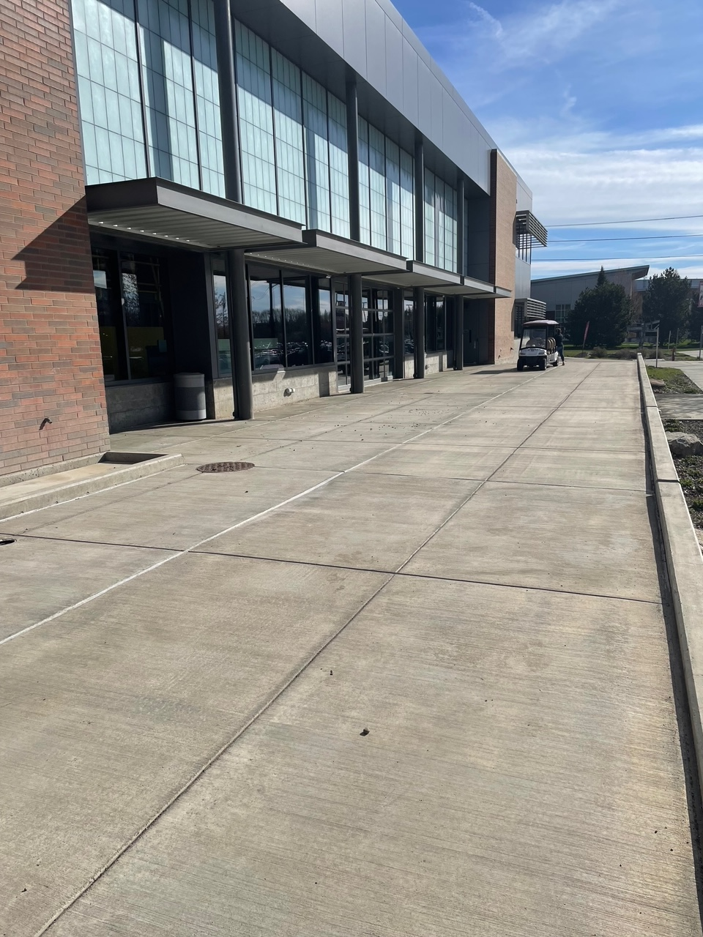
Figure 01 – South side of Houge (Runway)

- Ensure a clear distance of 30ft with no obstructions using the rope tape measure.
- Measure the distance using the rope tape measure of 20ft and place painters’ tape at start point (0 ft) and the end point (20ft).
- Setup excel on laptop.
  - Be sure to include a column for each of the five test runs.
  - Include rows for Time, Distance, and observations.
  - Include rows for calculated values, velocity and acceleration.
  - Refer to Figure 02 below.
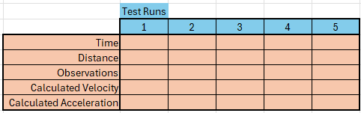
Figure 02 - Example Data Table

- Setup a cell phone to record the device during each test run.
  - Can be recorded in hand (no tripod necessary)
  - Video can be start before the test begins and can be ended after the test is complete.
- Setup a stopwatch to record the time of each test run.
  - Can use a cellphone if necessary
- Start the test by lining the RC Baja Car up to the start point tape (done in step 4).
- Simultaneously as the vehicle takes off from the start point on the runway begin recording on the stop watch.
- When the vehicle reaches the finish line (end point determined in step 4) stop the stop watch.
  - Record the data in the time row for the first test run column (time it took to get from start to finish).
  - Record any observations of the test (anything that stood out, poor behavior of the device, loss of traction)
- Replicate steps 8 – 10. Fives times to ensure adequate date.
  - If the stop watch is started or ended late record the date but strike through the test add an additional column and perform the test again.
- Once all data is gathered the velocity and acceleration can be calculated using a calculator and the recorded data within the excel sheet.
- Velocity can be calculated using the distance divided by the recorded time.
  - In this case the distance is fixed at 20ft and the time is that in which was recorded for each test.
  - Log the calculated velocity to the excel sheet.
- Acceleration can be calculated using the change in velocity divided by the change in time.
  - In this case the change in velocity is the value calculated in step 13 being the starting velocity at rest is 0.
  - Use the recorded time for each test run.
  - Log the calculated acceleration to the excel sheet.
- Repeat steps 12 – 14 for each test run that was performed.
- Save the excel sheet, all of the required data has been found.
- Begin tear down of the runway.
  - Collect all measuring devices and return to the appropriate location.
  - Remove painter’s tape from start and finish line of runway.

Deliverables

Appendix G1.1 – Procedure Checklist

Appendix G1.2 – Data Forms

Appendix G1.3 – Raw Data

Appendix G1.4 – Evaluation Sheet

Appendix G1.5 – Schedule (Testing)

Appendix G2 - Material Testing

Introduction

Method/Approach

Test Procedure
Summary/Overview:
This procedure documents the process of recording and testing material for the RC Baja Car to determine material properties. The RC Baja Car was built by students within the CWU MET program for the ASME RC Baja Car competition. This test coincides with the dimensional requirements within the ASTM standard D638. Utilizing molds, test samples, and Instron Machine. The following information describes the test information and procedure to replicate the test.

Time:
The test was conducted on 1/30/24 from 8:00am – 10:00am in Houge room 127. A total of 15 minutes is necessary for setup and clean up. If the test samples have not been created a time of 6 hours will be necessary to pour test sample into molds and let set. If the test samples have been completed an additional 30 minutes on top of setup and cleanup is necessary to test on the Instron.

Place:
Inside Houge Hall room 127 (Materials Lab), Central Washington University campus in Ellensburg, WA.

Required Equipment:
- One cell phone to record.
- Laptop with excel or google sheets.
- ASTM standardized test samples.
- Instron Machine – Model 34SC-5.
- Thumb drive.

Risk/Safety:
Risk associated with the test can be mitigated by ensuring all measurements are accurate, the test samples are accurate to ASTM D638 standard, along with ensuring the Intron is calibrated correctly.

Safety associated with the test is prevalent as the material is stretched during the test with a rapid break. The likeliness of material breaking off and shooting out is likely therefor safety glasses are required to be wore while testing is in place.

Test Procedure:
- Collect all testing equipment and place near Instron Machine.
  - Test samples.
  - Safety glasses.
  - Thumb drive.
- Set up the Instron Machine.
  - Make sure the computer is logged in.
  - Turn on the Instron Machine with the power switch on the back.
  - Select Blue Hill application from the home screen.
  - Once Blue Hill is opened a CWU professor must sign in using an admin account.
- Setting up the test.
  - Once fully logged in to the Blue Hill test application select quick test option.
  - Make sure the units are applicable to the test, in this case inches and pound force.
  - Set the test direction to stretch rather than compression.
  - Set the test speed to 1/8” per minute. (This will allow students to see flaws or stress concentrations as the test takes place.)
- Set up Instron Machine test fixture. (Refer to fig 01)
  - Make sure the “clamps” are used on both the top and bottom of the test fixture. As the ASTM D638 test sample will be placed between the clamps and stretched.
  - Clamp the test sample into the test fixture by sliding the chrome piece down.
  - Tighten the bolts of the clamp and make sure the test sample is held tightly.
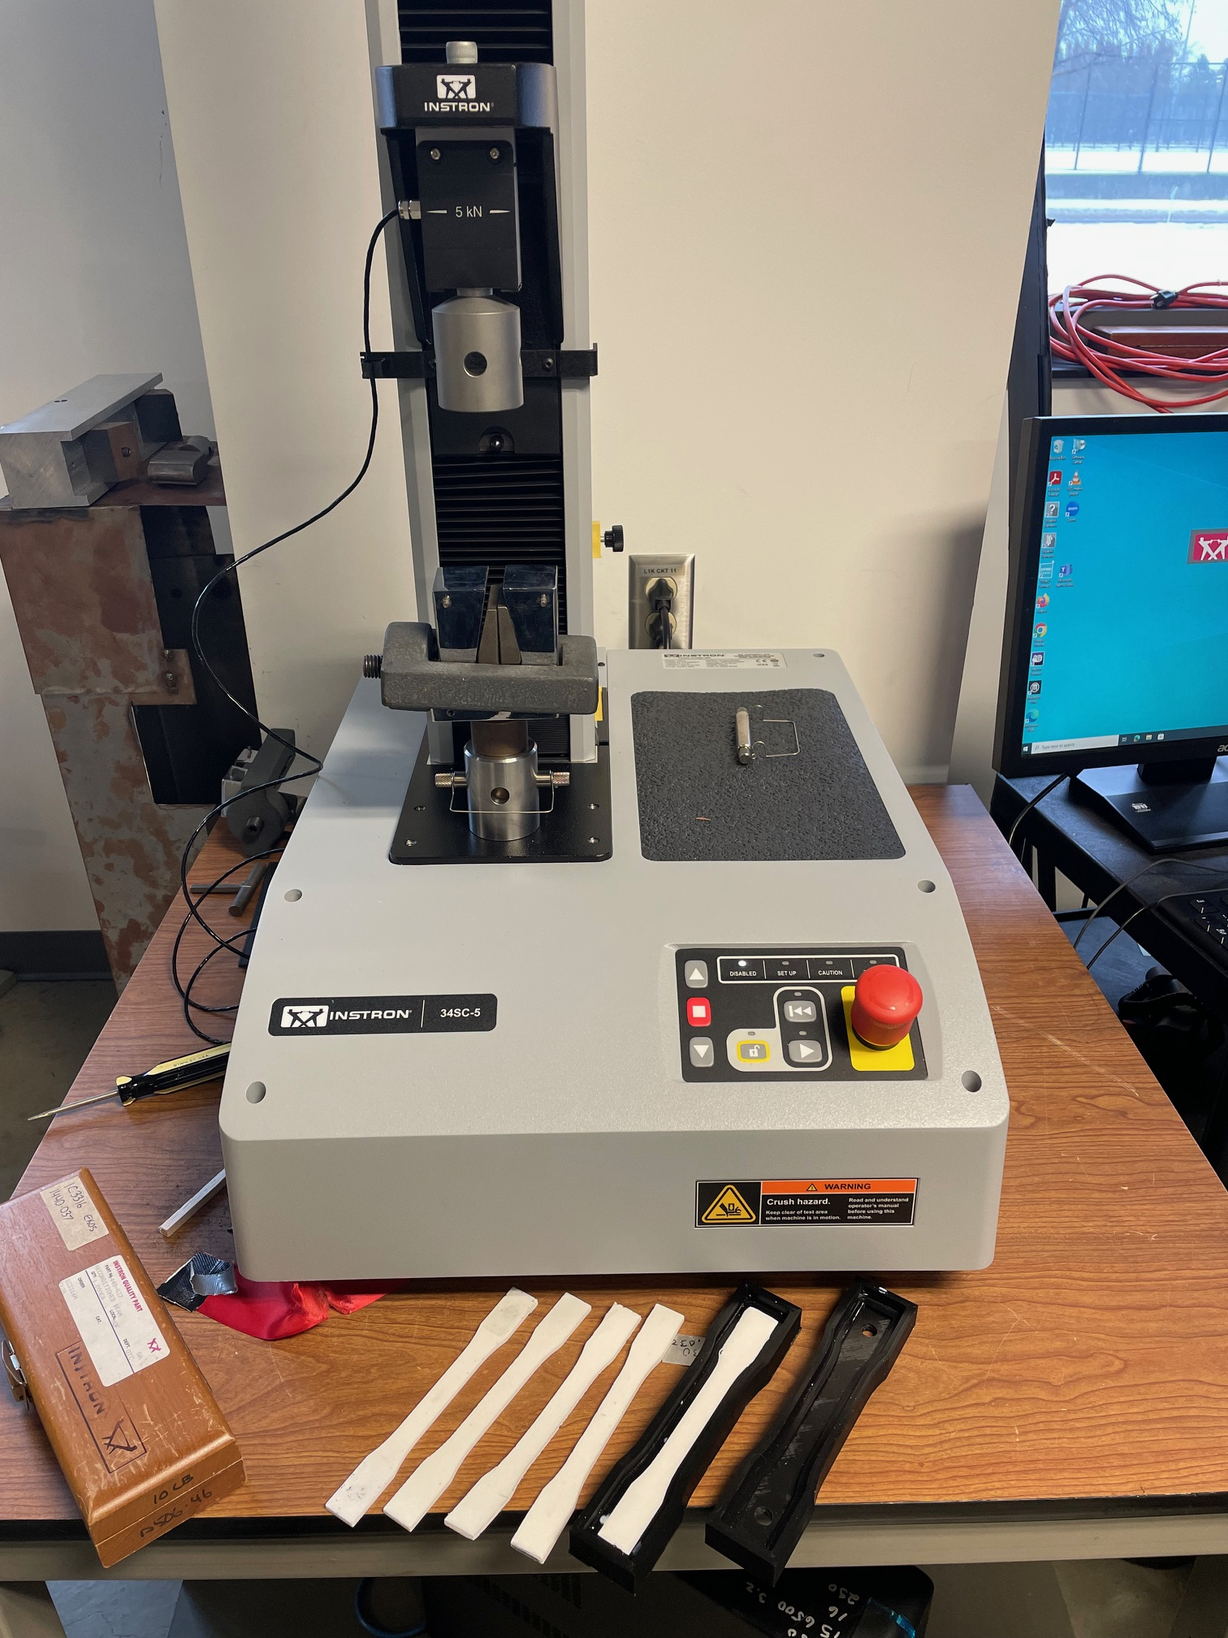
Figure 01 – Instron Machine with clamps
- Starting the test.
  - Make sure the estop button is off.
  - Start the test by pressing the start test button on the computer.
- Watch the test take place, as the test sample stretches see the deformation taking place and the force values for displacement.
- As this is simply material research used in order to determine the young’s modulus value, there is no specific values to look for.
- Once the test sample breaks, remove it from the clamps and replace it with another sample.
- Repeat steps 5-8 4 more times.
- Once all tests are completed save each trial folder to the thumb drive and remove the last test sample.
- Clean up the surrounding area and log out of Blue Hill and the Instron Machine computer.
- The test will come out to look like that in figure 02.
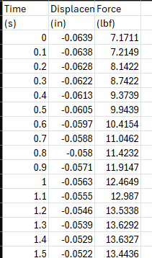
Figure 02 – Test trial data sheet

- Calculate the stress by dividing the force by the area of the test samples.
- The equation will look like this Stress = Force/Area
- Then graph the stress over the strain to find young’s modulus. Shown below in figure 03.
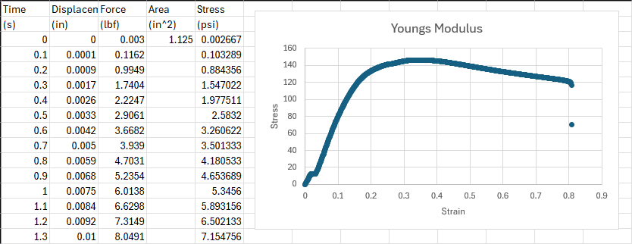
Figure 03 – Test trail data sheet after finding young’s modulus.
- This young’s modulus can be plugged into the deflection formula to determine whether this material is suitable for the chassis.

Deliverables

Appendix G2.1 – Procedure Checklist

Appendix G2.2 – Data Forms

Appendix G2.3 – Raw Data

Appendix G2.4 – Evaluation Sheet

Appendix G2.5 – Schedule (Testing)

Appendix G3 – Chassis Deflection Test

Introduction

Method/Approach

Test Procedure
Summary/Overview:
This procedure documents the process of recording and testing the chassis for the RC Baja Car to determine if deflection of the chassis meets requirements. The RC Baja Car was built by students within the CWU MET program for the ASME RC Baja Car competition. This test utilizes the Instron Machine. The following information describes the test information and procedure to replicate the test.

Time:
The test was conducted on 4/22/24 from 8:00am – 10:00am in Houge room 127. A total of one hour is necessary for the test. 15 minutes for setup within Bluehill on the Instron and the testing fixture. An addition 15 minutes is necessary for cleanup leaving 30 minutes for testing.

Place:
Inside Houge Hall room 127 (Materials Lab), Central Washington University campus in Ellensburg, WA.

Required Equipment:
- One cell phone to record.
- Laptop with excel or google sheets.
- Instron Machine – Model 34SC-5.
- Thumb drive.
- RC Baja Car chassis

Risk/Safety:
Safety associated with the test is prevalent as the material is compressed during the test with a rapid break or crack. The likeliness of material breaking off and shooting out is likely therefor safety glasses are required to be wore while testing is in place.

Test Procedure:
- Collect all testing equipment and place near Instron Machine.
  - RC Baja Chassis.
  - Safety glasses.
  - Thumb drive.
- Set up the Instron Machine.
  - Make sure the computer is logged in.
  - Turn on the Instron Machine with the power switch on the back.
  - Select Blue Hill application from the home screen.
  - Once Blue Hill is opened a CWU professor must sign in using an admin account.
- Setting up the test.
  - Once fully logged in to the Blue Hill test application select quick test option.
  - Make sure the units are applicable to the test, in this case inches and pound force.
  - Set the test direction to compression rather than stretch.
  - Set the test speed to 1/8” per minute. (This will allow students to see flaws or stress concentrations as the test takes place.)
- Set up Instron Machine test fixture. (Refer to fig 01)
  - Make sure the correct test fixture is in place, a three point load (the pieces look like 3 nubs).
  - Lay the chassis into the test fixture as close to center as possible.
  - Bring the center point load as close to the chassis using the up and down arrows on the Instron before starting the test.
Figure 01 – Instron Machine
- Starting the test.
  - Make sure the estop button is off.
  - Start the test by pressing the start test button on the computer.
- Watch the test take place, as the test sample compresses see the deformation taking place and the force values for displacement.
- As this is test is done to verify analysis and requirements the chassis must not deflect more than 5/16 of an inch.
- Once the chassis reaches the load during analysis (18lbs), remove it from the fixture and record the deflection.
- Repeat steps 5-8, 4 more times.
- Once all tests are completed save each trial folder to the thumb drive and remove the last test sample.
- Clean up the surrounding area and log out of Blue Hill and the Instron Machine computer.
- The test will come out to look like that in figure 02.
Figure 02 – Test trial data sheet

Deliverables

Appendix G3.1 – Procedure Checklist

Appendix G3.2 – Data Forms

Appendix G3.3 – Raw Data

Appendix G3.4 – Evaluation Sheet

Appendix G3.5 – Schedule (Testing)

Appendix H – Resume

Objective: My goal is to expand and further my knowledge as a Mechanical Engineer in the Automotive Industry.

BOE HARTMAN
Ellensburg, WA · 509-xxx-xxxx · xxxxxxx@gmail.com

Education:

Central Washington University

9/22/2021 – spring 2024 - MEchanical engineering technology bs

yakima valley college

9/14/ 2019 – June 2021 - ASSOCIATE of Arts

Experience:

PACCAR

6/12/2023 – Current On Board Dianostics (OBD) Calibration Engineer intern
Duties:
- Utilized ATI VISION, CANalyzer, and tools within the ETL to analyze data from trucks both in Dyno and on the road.
- Interpreted data through MATLAB to manipulate calibrations to better increase vehicle performance with regards to emissions laws and regulations.
- Processed data and ran simulations to assess issues with postproduction calibrations.
- Dived deep into digital filters that make up calibrations within the diagnostic, specifically a constant within.
- Performed in truck testing using various forms of failed parts.

Fisher Construction Group

6/05/2022 – 2/8/2023 Project engineer intern
Duties:
- Maintain and create schedules for other staff.
- Host and partake in various meetings with different contractors and suppliers throughout the week to ensure proper coordination and timeliness.
- Draw and create specification sheets which are used for advertising on prospective jobs.
- Various testing and trials on newly assembled equipment.

Autozone

9/13/22 – Current Parts Sales Manager
Duties:
- Cashier – Help customers find the specific parts they need in a timely fashion.
- Delivery Driver – Take parts deliveries to nearby mechanics shops and car dealerships.
- Parts Sales Manager – Work with commercial accounts and help cashiers when needed, while creating and publishing schedule along with verifying loss prevention.

Skills/Attributes:
- 2D & 3D Design/Modeling
- CNC Machining
- Solidworks
- MATLAB
- CANANALYZER
- ATI Vision
- OBD Toolsuite
- Simulink
- Computer Skills (MS Office 365, CAD, Autodesk Applications)

- Various Machinery Experience
- SME President
- Management Experience
- Team Player
- Problem Solver
- Communication Skills
- Organization
- Customer Service

